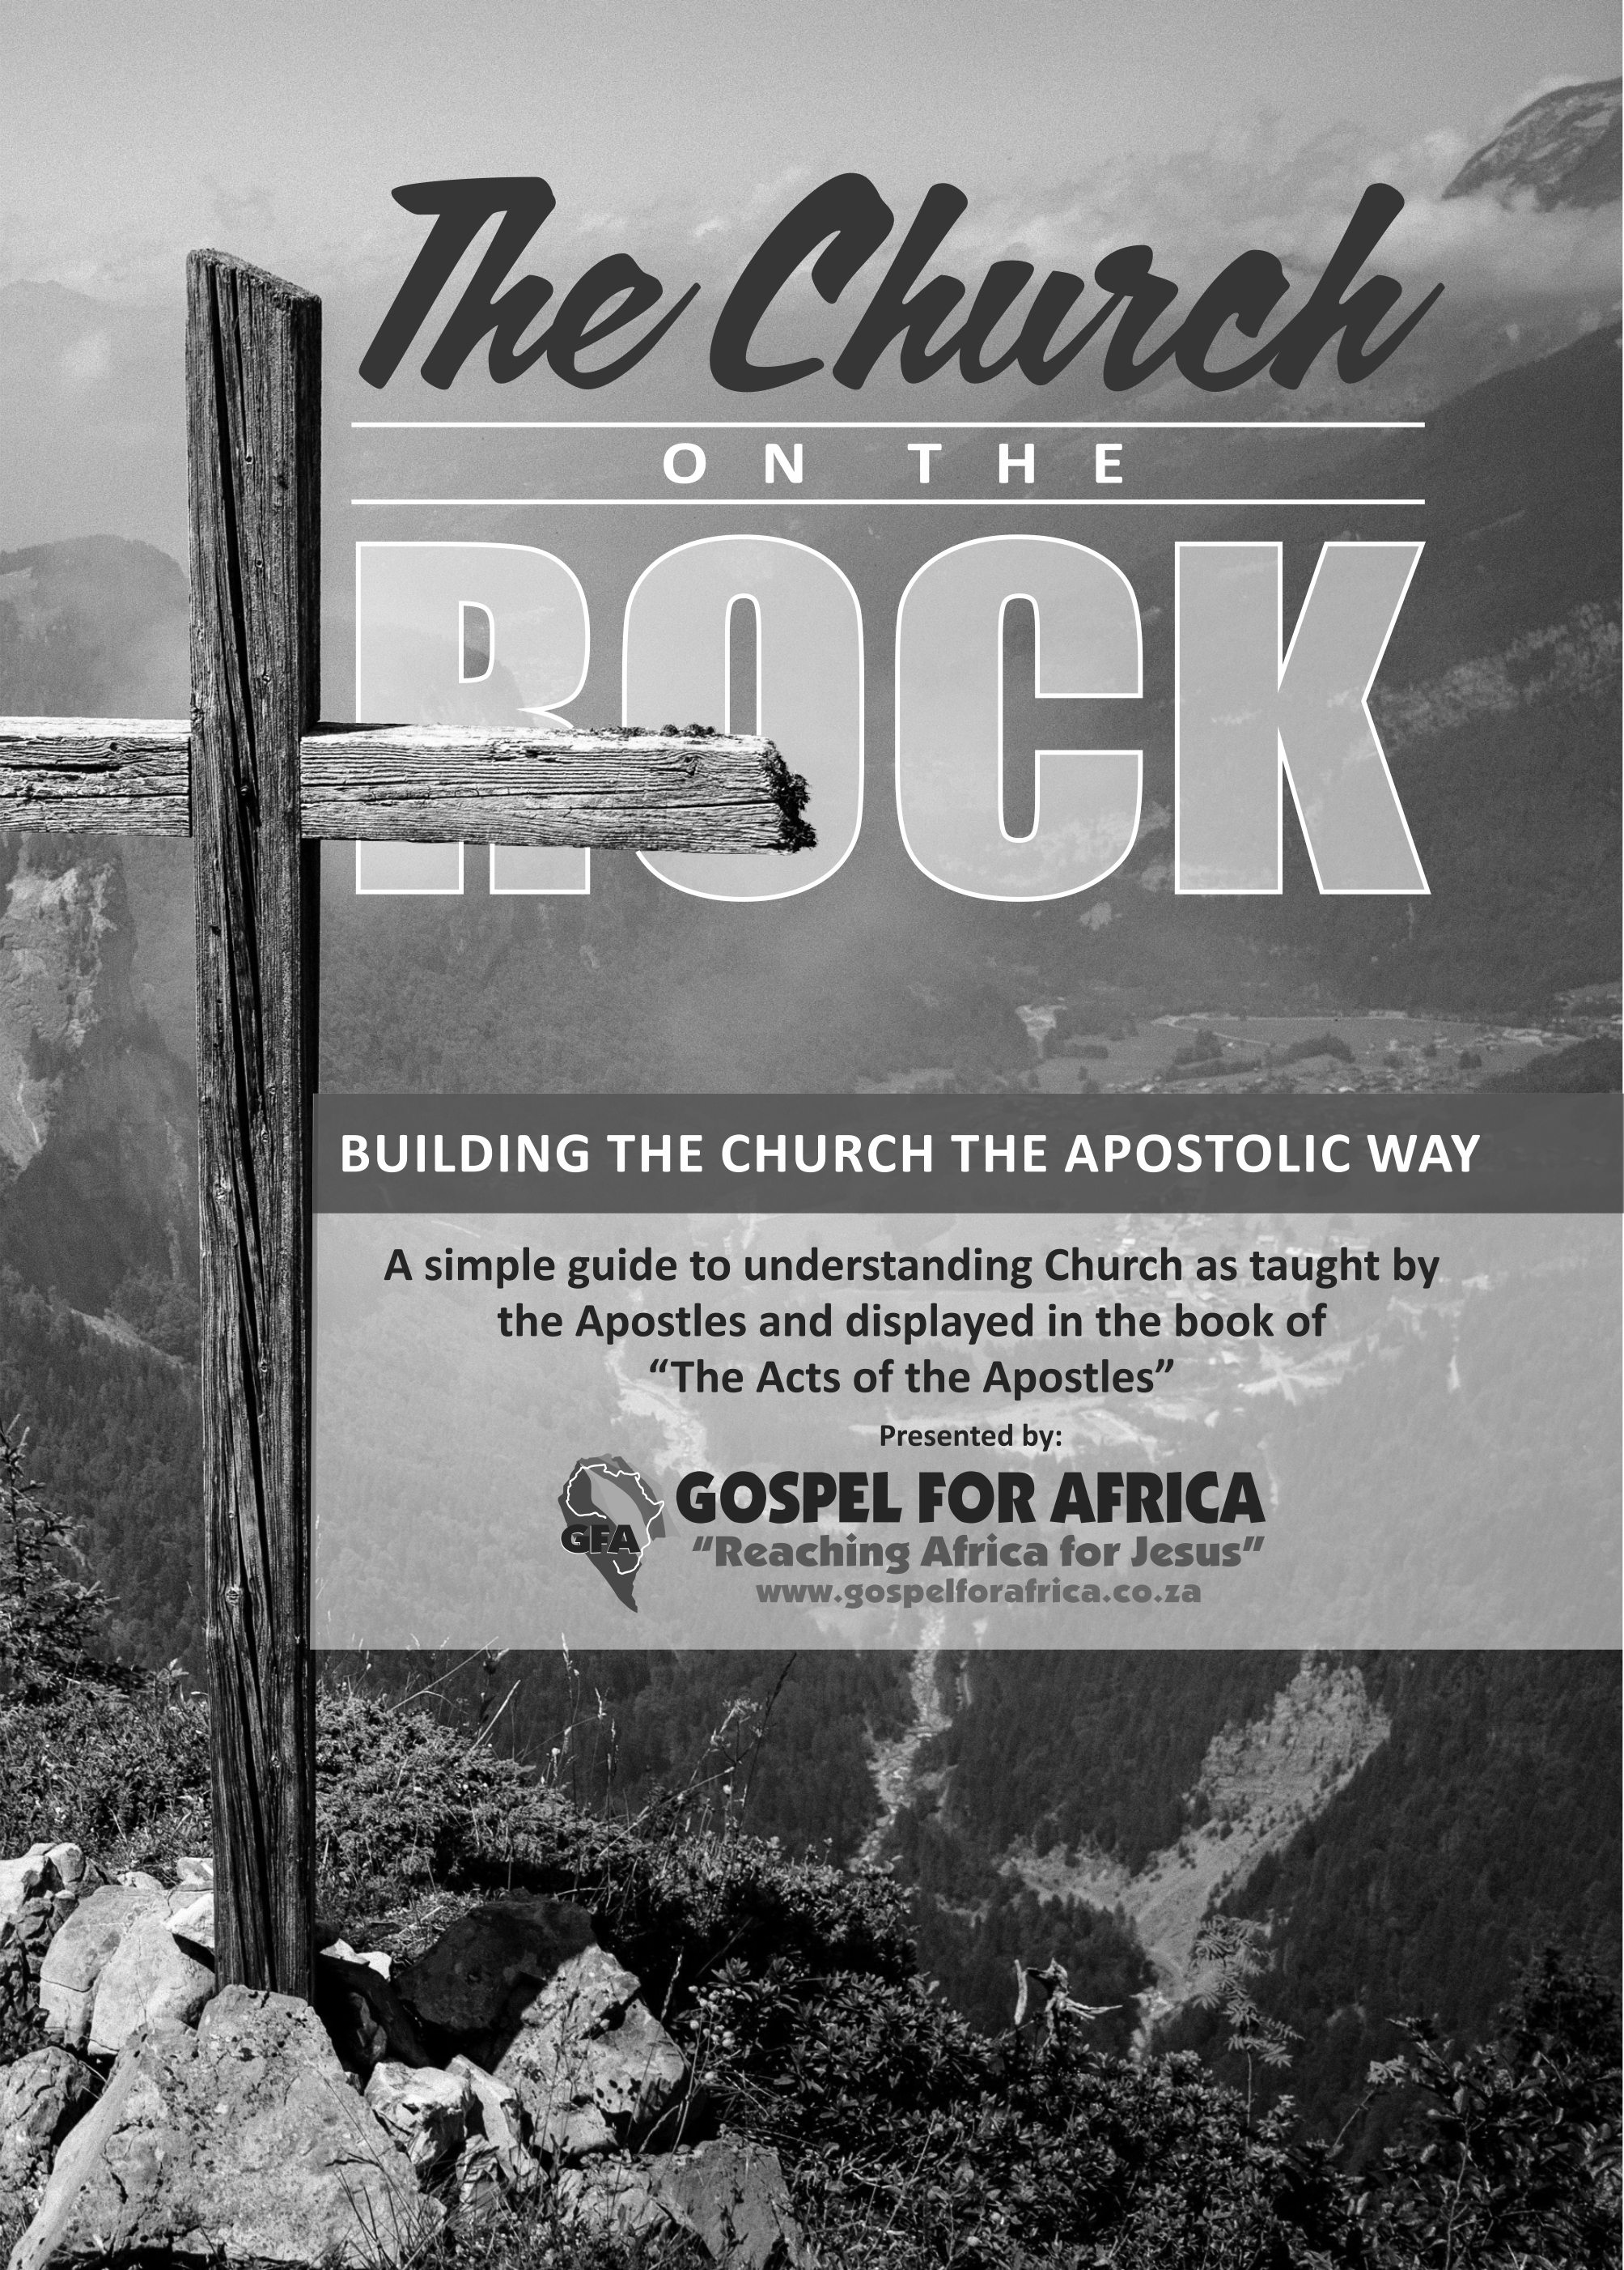

PREFACE

This is by no means a comprehensive book, but rather a “REFERENCE GUIDE” that should ideally be used at our Church leader training conferences.
Obviously, you may have come upon this booklet without having attended the leadership training and therefor will ONLY be able to understand the doctrinal truths conveyed and unfortunately not the
“HEART” of this Apostolic Vision as would be conveyed during our training times.
The FOUNDATION of the Church is “Jesus Christ and Him crucified” and
the HEART of this foundation is conveyed primarily by men who have
been broken before God and are totally surrendered to His will (Luke
22:41-42 & Luke 9:23-24).
Men who are NOT concerned with titles nor positions but the spiritual development of Church leaders who will give themselves to building their churches on the ONE and ONLY FOUNDATION - Jesus Christ (1 Corinthians 3:10 & Galatians 4:19).

The church having moved from the Apostolic teachings, together with a warning from the Apostle Paul in 2 Timothy 4:1-4 that the church would “no longer endure sound doctrine” in the last days, has been the primary motivation for the development of this manual.
Every reader would be wise to carefully examine the foundation they are currently building on (1 Corinthians 3:10-15), study to show themselves approved of God (2 Timothy 2:14-16) and take seriously the working out of their own salvation (Philippians 2:12-18).
I have used the King James Version as the biblical text, with Strong’s Hebrew and Greek dictionary to bring clarity and a better understanding to the Greek words in potentially confusing contexts.

PLEASE use your Bible together with this reference guide to check and verify all scripture being referenced.

WHO IS GFA?

- Network of Churches (NOT a denomination)
- Functioning in relationship (NOT by organisational structure)
- Connected in our hearts (NOT by constitution)
- Focused on building the Church of Jesus Christ
- Building ONLY on the foundation Jesus Christ
- Following the teachings of the Apostles

OUR VISION
We as a network of Churches in sincere relationship with one another are building the Church of Jesus Christ on the African continent in accordance with the Apostolic foundation.

THE OBJECTIVES

- Network with like-minded Churches
- Build relationships leading to unity in the Spirit and the Faith
- Ensure the Church remains the “ground and pillar” of truth
- Clearly present the Apostolic vision
- Develop Godly character in Church members
- Train, develop, equip and send native missionaries
- Build Apostolic teams in each nation, region and continent

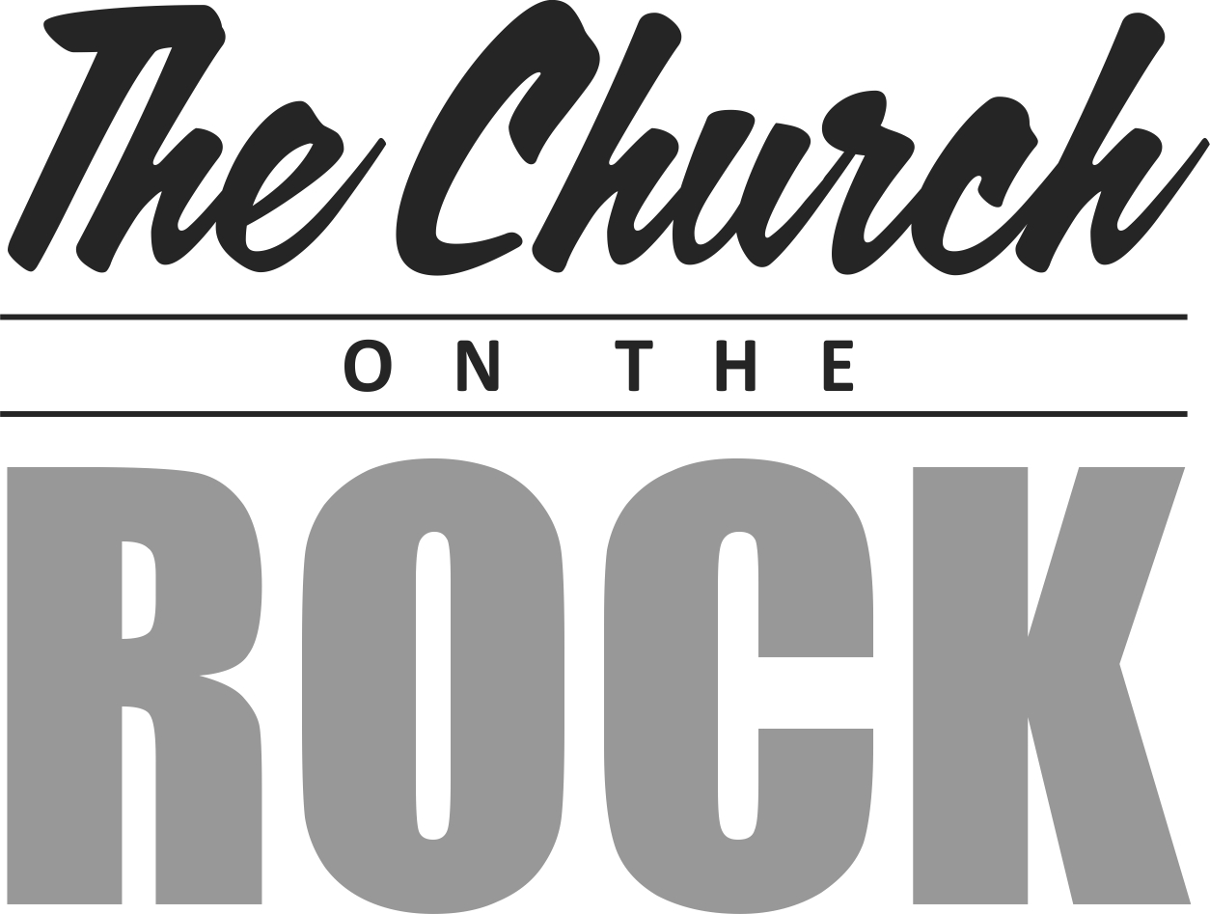

Index

Chapter 1: What is the Church? 7

Chapter 2: How do we build the Church? 13

Chapter 3: How should the Church function? 16

Chapter 4: Church Administration 32

Chapter 5: Spiritual Gifts 50

Chapter 6: Every Believer is a Priest 57

Chapter 7: What about Women? 59

Chapter 8: Tithing & Giving God’s Way 61

Chapter 9: Church Discipline 67

Chapter 10: Character shaped by God 72

Chapter 11: Strong Family Units 85

Chapter 12: What happens at the End? 90

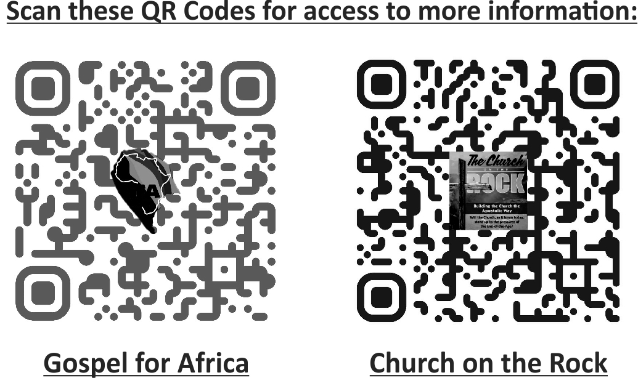

Chapter 1

- WHAT IS THE CHURCH? -

Strong’s Greek Lexicon: G1577
Greek: ἐκκλησία
English: ekklēsia
Pronunciation: ek-klay-see'-ah
From a compound of G1537 and a derivative of G2564; a calling out, that is, (concretely) a popular meeting, especially a religious congregation (Jewish synagogue, or Christian community of members on earth or saints in heaven or both): - assembly, church.

The word church appears 80 times in the King James Version.
The word church simply means “the called-out ones”.

UNDERSTANDING THE MEANING
Quite simply, the church is a group of people who have been “called out”.
Although still in the world physically, they are not of the world spiritually.

John 17:6-18
This group of people, “the called-out ones”, are the true church of Jesus Christ.
The church is not a physical building, institution, organisation, denomination or any such thing made by man.
The church is God’s spiritual building that is no longer of this world, yet physically still in this world to manifest His glory.

Let’s look at what God says concerning His church.

- God doesn’t dwell in a physical building.
Acts 7:48-50 and Acts 17:24-25

- We are the temple of God.
1 Corinthians 3:16-17, 1 Corinthians 6:19-20 and
2 Corinthians 6:16

- We are a spiritual house.
1 Peter 2:5

- Jesus is the head of His church, which makes up His body.
Ephesians 1:22-23, Colossians 1:18, Romans 12:4 -5
and 1 Corinthians 12:12, 15

Christ is therefore not separate from His church but one with her as the “head” of the body.

1 Corinthians 6:15-17
Together with Christ we have become one spirit.
This takes place when we are “baptized into Jesus Christ” and are “born again” (in the spirit).

“Baptised into Jesus Christ”
(Romans 6:3, 1 Corinthians 12:13 and Galatians 3:27
“Born again”
(John 3:3-7)
When I believe on Jesus Christ and call on His name for salvation, I am baptized into His body and His Spirit enters into me.
This is the process of the new creature being filled with the Spirit of Christ. God’s Spirit is joined to my spirit, giving my spirit LIFE.

Romans 7:4 teaches that we are “married” to Christ.

2 Corinthians 5:17 and Luke 5:37-38
Only a “new creature” (new bottle) can receive the Spirit of Christ (new wine).
So, everyone who is “born again” is recreated by God (becomes a new creature) and made a member of His “body” (the church) in which He dwells by His Spirit.
The church is therefore a spiritual building, no longer of the world spiritually, yet a new creation of God remaining in the world physically to manifest His glory.
To become a member of this church is a miracle, the greatest gift humanity can receive and the highest calling to be pursued. We have passed from the temporal into the eternal; we have become laborers together with Christ in the building of God’s eternal temple.

THE CROSS

Understanding the “cross” is critical to understanding the “New Testament” Church and will eliminate many of the errors and confusion we are facing today.

To understand the cross better, we need to understand the “2 Covenants” (old and new).
In the Old covenant God calls Abram to leave his country and family and to follow Him to a land of “Promise”.
God also promises a “seed” (singular descendant) to Abram through which “ALL” the nations of the earth would be blessed Genesis 12:1-4, 15:1-6.
God then changes Abram’s name to Abraham: him and Sarah have a child miraculously and they name him Isaac.
Isaac was a promised son yet not the promised “seed”, as it would be through the promised seed that “ALL” the nations of the earth would be blessed. Isaac was a father to a singular nation called Israel as we see that his son Jacob had his named changed to “Israel” by God.
Abraham, Isaac and Jacob(Israel) are the fathers of this new nation (people group) that God sets apart as His special people to fulfill His purposes.
It was only this nation that was blessed by God until Jesus who was born of the tribe of Judah fulfilled this promise. Jesus was the promised seed through who all nations would be blessed Galatians 3:15-29

Jesus then ushers in a “New Covenant” Luke 22:20 in His blood.
There needed to be the shedding of blood for the forgiveness of sin Mathew 26:28 and Hebrews 9:22.

It is the cross that separates the 2 covenants, putting an end to the old and making way for salvation to all in the new Galatians 6:14.
So, in the new covenant, the blessing (salvation) is only found in Jesus.
No longer is there a need for sacrifices as Jesus is the “once for all” sacrifice Hebrews 9:25-26.
He put an end to the law Romans 10:1-4, introducing a new law Romans 8:1-4, the law of the Spirit of life.
The cross introduces “Faith” as the promised seed Jesus has come Galatians 3:6-9, 14, Romans 4:13-25 and by His blood paid the price for sin and opened the way to the Father.
We now have access by “Faith” into this “GRACE” Galatians 2:8-9.
The work of the cross is appropriated to our lives and so we too are “crucified” with Christ Galatians 2:19-20, becoming dead to the law Romans 7:4-6 and now serving in the newness of Spirit Romans 8:9-10.

The New Covenant Church needs to understand the cross to enjoy the blessings that came to us in Jesus (the promised seed) to enable us to live in His fullness.
This is why Paul said to the Corinthians; I don’t want to know anything else among you except Jesus Christ and Him crucified 1 Corinthians 2:2. Paul boasted only in the cross Galatians 6:14.

The purpose of the cross in our lives is to crucify the flesh that we may live in the Spirit. The cross will bring rejection, opposition, persecution, suffering and death, all of these are necessary in the life of the believer to manifest the life of Jesus.

For Jesus to increase, I must decrease John 3:30.

If we don’t have this understanding as the New Covenant Church, we mix the 2 covenants resulting in the following;

- Dual covenant theology (Living under both covenants)
- A life of condemnation under the law (Never good enough)
- A life of justification by works (No faith leading into works)
- Wrong leadership styles (“1 man” show and hierarchical)
- Only the prophet has an anointing and is God’s mouthpiece
- Legalistic application of tithing
- Over emphasis on physical blessings and prosperity
- General legalistic application (Over emphasis on the external)
- Not understanding that suffering works for our good
- No power to overcome sin (Making people like pharisees)

It is necessary therefore to always have the cross as foundational to all we do.
Jesus said that if we want to be His disciples we need to daily “deny ourselves, take up our cross and follow Him” Luke 9:23.

So as the New Covenant (New Testament) Church we live by the Spirit of Christ who indwells us and no longer by the old covenant law. We do this in accordance with the “Apostle’s doctrine” Acts 2:42 and not trying to mix old and new.

Chapter 2

- HOW TO BUILD THE CHURCH -

So how is the church built? Who are the builders and what is it built with?

1 Corinthians 12:4-6
The three persons of the Godhead, viz. Father, Son and Holy Spirit, are intricately involved in the building of the church. The above-mentioned scripture presents their collective functions:

Father: Different operations - Acts 2:42-47
Son: Different administrations - Ephesians 4:11-16
Holy Spirit: Different gifts - 1 Corinthians 12:7-11

Let’s look at each of these functions as given to us by God.

DIFFERENT OPERATIONS

Acts 2:42-47
On the day of Pentecost, Peter preached and 3000 people were born again. They were baptized in water and immediately entered into the following operations:
- Apostles’ doctrine 1 John1: 1-3, Hebrews 6:1-2
- Fellowship 1 John 1:5-7
- Breaking of bread 1 Corinthians 10:16-17, 21
- Prayer

DIFFERENT ADMINISTRATION
Ephesians 4:11-16
We read in the above scripture that when Jesus ascended back to His Father, he gave the following ministry gifts to men for the equipping of believers to become actively involved in the building of His church.
- Apostles
- Prophets
- Evangelists
- Pastors
- Teachers
DIFFERENT GIFTS

1 Corinthians 12:7-11
We see in the above passage that the Holy Spirit empowers the believers with the following gifts.
These gifts are for the building of the church and are imparted supernaturally as and when needed.
- Word of wisdom
- Word of knowledge
- Faith
- Gifts of healing
- Working of miracles
- Prophecy
- Discerning of spirits
- Diverse kinds of tongues
- Interpretation of tongues

It is with reference to the above-listed “operations, administrations and gifts” that Jesus said in Matthew 16:18, “Upon this rock I will build my church; and the gates of hell shall not prevail against it.”
It is therefore evident that the building of the church is all of God; man simply becomes the vessel through whom God works by His divine abilities.

We will discuss these functions in more detail in the next chapter.

Chapter 3
- HOW SHOULD THE CHURCH FUNCTION? -

- Apostles’ doctrine
- Fellowship
- Breaking of bread
- Prayer

Remember the church is a spiritual building so can only be built with “spiritual materials”.
Having been born again, we pass from the natural to the spiritual.
This becomes a struggle for us as we have lived our lives in the natural for many years and now have to slowly make the transition to the spiritual.
Initially, God’s ways appear foreign to us because we are still operating naturally.
God enables us to make the transition into the spiritual operations through the “Apostles’ doctrine”.

APOSTLES’ DOCTRINE
This is the doctrine received directly from Jesus and taught by the Apostles (the 12 Apostles and Paul).

The 12 Apostles (the Apostles of the Lamb) were taught directly by Jesus - Acts 1:2-3.

When choosing an Apostle to take the place of Judas, the following criteria needed to be met - Acts 1:21-26.
It is therefore clear that there were no further Apostles of the Lamb after Matthias.

Paul was an Apostle who was also taught directly by Jesus when he was caught up into heaven - 2 Corinthians 12:1-7 and
Galatians 1:11-12.

The above-mentioned Apostles were taught directly by Jesus and wrote the New Testament Scriptures.

Apostles are responsible for laying the foundation which is Jesus Christ - 1 Corinthians 3:10-11, Ephesians 2:20 and
Hebrews 6:1-3.

Jesus is the foundation, taught to us by the Apostles as “the principles of the doctrine of Christ” - Hebrews 5:12, 6:1.
These principles are therefore foundation blocks on which all doctrine is built.
So, according to Paul, Peter and the writer of Hebrews, every new believer (newborn babe) needs the “milk of the word” (principles) to grow before they can partake of the “meat” (doing God’s will).

1 Corinthians 3:1-3, 1 Peter 2:1-2 and Hebrews 5:12-14
“The milk of the Word” is therefore the foundation / principles / building blocks which set the platform for a newborn babe or carnal / fleshly believer to grow into being a partaker of “meat” (becoming of full age / spiritual), those who are able to discern the will of God.

It is then clear from these scriptures that every new or carnal believer (one who still thinks naturally or is still fleshly) needs to be grounded in the principles, which will give them the ability to discern and then do the will of God.

Jesus tells us that “His meat” is to do His Father’s will and to finish His work - John 4:31-34.

Meat is therefore not understanding deep doctrines but rather doing God’s will.
So, without the foundation of the milk, we will not be able to partake of meat and do God’s will.

Jesus put it like this in Matthew 7:21-27.
So, in order to enter the Kingdom of Heaven, we need to do the will of God. It is not enough to simply say: Lord we have done all these works.
He makes this radical statement in the same context as the need to be built upon the Rock (foundation /principles /milk).
It is imperative that every believer is established in the principles to be equipped to discern God’s will for themselves.
Doing “works” for God in His name is not what we should focus on, but rather discerning and doing His will.

In Hebrews we are given a list of the “building blocks” that make up this foundation - Hebrews 6:1-2.
- Repentance from dead works
- Faith towards God
- Baptisms
- Laying on of hands
- Resurrection of the dead
- Eternal judgments
- Going on unto perfection

FIRST PRINCIPLES OF THE DOCTRINE OF CHRIST

2 Timothy 2:19
Timothy states that being built on the foundation of God assures us that we belong to Him.

Matthew 7: 21-27
Wisdom is building on the right foundation, not just knowing the Bible and being involved in Christian activities. Everything we believe and do will be tried, and only that which is built on Jesus the Rock will stand.

Matthew 16:13-18
The Father in heaven revealed to Peter who Jesus was. It’s this revelation from the Father that roots us on the rock. Knowing the Bible intellectually is insufficient; we must have our eyes opened to who Jesus is, and this comes ONLY by revelation.

Ephesians 2:19-22
This foundation is laid by apostles and prophets according to the ability given them by God.

1 Corinthians 12:28
Lists the order of functions regarding building the Church. God has set:
1st apostles - they lay the foundation
2nd prophets - they inspire us to build on the foundation
3rd teachers - they establish the doctrines on the foundation.

1 Corinthian 3:1-3
In this passage, Paul the Apostle makes it clear that a carnal (baby, new, immature, naturally minded) Christian needs the “milk of the Word” (foundation) to grow into spiritual maturity.

1 Peter 2:1-2
Peter the Apostle teaches exactly the same as Paul did concerning a carnal Christian.

Hebrews 5:12-14
The writer of Hebrews confirms what both Paul and Peter taught about a carnal Christian and then names the foundation as the “first principles of the doctrine of Christ”.
The writer of Hebrews then lists these principles, as we will read in the following Scripture - Hebrews 6:1-3.
Seven principles are listed in this foundation, giving us the revelation of Jesus Christ. We will now look at each one individually.

- Repentance from dead works: Repenting of self justification
The old nature (carnal) is predisposed to doing “works” for justification as it is motivated by a guilty conscience.
God can deliver us from this guilty conscience through faith in the sufficiency of the work of Jesus.
No work that originates from guilt is acceptable to God as it is from an evil motive and seeks self-justification and the end result is the glory of man. Man cannot attain righteousness by his own efforts!

Hebrews 9:11-14
God will purge my conscience from “dead works”, enabling me to serve the living God.

Ephesians 2:8-10
Salvation is only by grace (God’s divine enabling), accessed only through faith (trusting only in God’s provision – Jesus).

Romans 4:1-5
Abraham received the gift of righteousness by faith and not by works.

Therefore, when I come to understand that my works will NEVER justify me, ONLY then will I turn to God in true faith and receive His righteousness leading to Justification.

- Faith toward God: Trusting only in Jesus for justification
Having faith in the sufficiency of Jesus will cause me to surrender to the work of the Spirit in me that will then produce “good works” which are acceptable to God.
Faith towards God will continually lead me deeper in the Spirit and further from my natural (carnal) desires and glorification of self.

Hebrews 11:6
Only faith pleases God. Trusting in anything or anyone else is an offence because Jesus stated in John 15:5 that without Him we can do nothing.

Ephesians 2:8-10
Faith leads me into the good works God has prepared for us to walk in, and in doing this, I become His “workmanship”.

James 2:17-18
True faith will always be evidenced by good works, for when we yield to God, He uses us as vessels for His glory.

Galatians 2:20
Faith leads to the Spirit of Christ in me living through me, manifesting the life of Jesus.

Romans 10:17
Faith is increased through hearing the Word of God.

Hebrews 11:7
Because Noah believed God (faith), he built the ark and was therefore pleasing to God.
The result of Noah’s faith was the work of God and not Noah’s ability, so God gets the glory.

Faith in the completed work of Christ and His ability will lead to salvation and a life lived in the Spirit and no longer in the flesh.

- Doctrine of Baptisms:
Strong’s Greek Lexicon: G909
Greek: βαπτισμός
English: baptismos
Pronunciation: bap-tis-mos'
From G907; ablution (ceremonially or Christian): baptism, washing.

This word can be translated as an Old Testament ceremonial washing or a New Testament baptism.
In this instance, it refers to the New Testament baptism.
The root word is:
Strong’s Greek Lexicon: G907
Greek: βαπτίζω
English: baptizō
Pronunciation: bap-tid'-zo
From a derivative of G911; to make whelmed (that is, fully wet); used only (in the New Testament) of ceremonial ablution, especially (technically) of the ordinance of Christian baptism: - baptist, baptize, wash.

To baptize is to immerse fully and to be completely covered by.
There are four baptisms taught in the scripture, yet Ephesians 4:5 seems to contradict this.
This “ONE baptism” referred to in Ephesians is the initial baptism into Christ from which the other three emanate. Without this initial baptism, the rest are either meaningless or impossible.

- Baptism into Jesus Christ: My salvation is ONLY secure in Jesus.
When we put our faith in Jesus for salvation, we are baptized into Christ and are justified immediately.
We become new creatures in Christ, His Spirit enters into us, and we are “born again”.
We become members of His body and in Him have all things that pertain to life and godliness.

Here are some scriptures that teach this baptism:
Romans 6:3-4
Galatians 3:27
1 Corinthians 12:13
2 Corinthians 5:17

In Christ I receive son-ship and forgiveness of sin, and I am clothed in His righteousness. Everything I need I have in Him; identity, acceptance, assurance, victory etc.

- Baptism into water: Declaration of salvation, fulfillment of the righteousness of Christ that came by faith through baptism into Christ.
Water baptism seals my salvation by an outward declaration of my inward experience.
This is a declaration that I have been made righteous.

Here are some scriptures that teach this baptism:
Matthew 3:13-17
Matthew 28:18-20
1 Peter 3:18-21

By water baptism, I declare that I have died to my old life and have been raised in new life in Christ.

- Baptism into the Holy Spirit: Power to live the new life in Christ
Living the life that I have declared I am going to live can only be done by the power of the Holy Spirit.
It is this baptism into the Holy Spirit that makes available to me the power I need for this new life which is “supernatural”.
The Holy Spirit also makes available to me nine gifts for effectiveness in ministry.

Here are some scriptures that teach this baptism:
Luke 24:49
Acts 1:8
John 14:12-16
John 15:26
John 16:7-15

When we live in the Spirit, we are given revelation and led into truth, comforted and empowered to live to the full potential God has called us to.

- Baptism into the sufferings of Jesus Christ: Life lived in obedience to God’s will
Living life in the Spirit denies the flesh its passions, desires and will, causing it to suffer.
This suffering is difficult for us as we are living in these bodies, yet it is only through denying the flesh that we can walk in obedience to God’s will.

Here are some scriptures that teach this baptism:
Matthew 20:20-23, 26:36-44
2 Timothy 3:12
Philippians 3:10
1 Peter 4:1-2
Hebrews 5:7-8

Living in obedience to God is both liberating and enabling since I am freed from slavery to the flesh, becoming a vessel fit for God’s use.

- Laying on of hands: God works through His vessels.
As a result of the baptisms, we become a vessel through whom God can manifest His life.
We become a functioning member of His living body. This has a practical outworking, which is the fulfilling of the “measure of Christ” He has placed in you.
You are now an effective member of the body of Christ (His church).
The principle is not just the physical laying on of hands, but rather our being the hands of Jesus to accomplish His work.

The following examples are when hands were laid on people for various purposes:
Matthew 19:13-15 (Blessing the little children)
Mark 16:18 (Healing the sick)
Acts 8:17, 19: 6 (Receiving the Holy Spirit)
Acts 6:6 (Recognising the ministries)
1 Timothy 4:14 (Receiving spiritual gifts)

Matthew 10:8 makes it abundantly clear that having freely received, we should freely give.
We become a blessing when we take what God has given to us and impart it to others; that why it is more blessed to give than receive (Acts 20:35).

- Resurrection of the dead: All of humanity will be raised.
Every human individual will be raised from the dead, believers to an eternity with Jesus and unbelievers to an eternity damned to torment in the “lake of fire”.
This is the hope of every believer, that we will one day put off this physical body with all its constraints and put on a spiritual body that has no constraints.

Here are some scriptures about the resurrection:
John 5:25-29
John 11:25-26
1 Corinthians 15:12-26, 35-54
Philippians 3:11

With this hope as our reality, we can be the vessels God has called us to be, in spite of life’s challenges and difficulties. The resurrection encourages us to endure faithfully to the end.

- Eternal Judgments: All of humanity is accountable to God.
There are various eternal judgments, all bringing about an accountability and a sober desire to live holy lives.
Hebrews 9:27
Romans 5:12 (Adam introduces sin)
1 Peter 3:18 (Jesus introduces righteousness)
1 Corinthians 11:31-32 (Self-judgment)
1 Corinthians 3:11-15 (Believers’ judgment)
Revelation 20:11-15 (Unbelievers’ judgment)

Understanding these judgments will enable us to live according to God’s will.
We are motivated to reach unbelievers with the good news of salvation and to glorify God in how we live so we can stand before Him and give a good account of our lives.

- Going on unto perfection: Maturing into the person God called us to be
When God is pleased that the foundation in our lives has been laid correctly, He permits us to go on unto perfection (spiritual maturity) - Hebrews 6:3.
This is God’s desire for all His children because it’s in this that we are true disciples and the Father is glorified because we bear much fruit - John 15:8.

The following scriptures instruct us in our maturing in Christ:
Hebrews 10:14
Philippians 3:8-14
1 John 3:2
Philippians 2:12

Once these principles have been established in us, we begin to discern and move into God’s will for our lives. They enable us to align with what God is doing and bring us into the good works He preordained for us to walk in – Ephesians 2:10.

In conclusion, we see that it’s these “teachings of the Apostles” that will bring us into true fellowship with God, and as we each come into fellowship with God, we come into fellowship with one another.

At the time of the Apostles, the Church had no buildings so they would gather in public facilities, as well as in homes, to hear the Apostles teach - Acts 2:1-2.

Acts 2:46, Acts 5:42, Acts 12:12, Romans 16:5 and
1 Corinthians 16:19
So, depending on the environment we live in and the availability of facilities, we must follow the same pattern. The emphasis should not be on the place of worship but rather continuing steadfastly in the teachings of the Apostles, fellowship, breaking of bread and prayer.

We will now discuss the next operation (function).

FELLOWSHIP
Fellowship is described by the Apostle John in - 1 John 1:1-7.
As we receive the teachings of the Apostles (light / revelation of Jesus) and we walk in these teachings, we come into “fellowship” with Jesus Christ and then one another.
So fellowship takes place when we walk in the light (teachings of the Apostles), bringing us into unity with Jesus and one another.

1 John 1:4
Being in fellowship with Jesus and one another keeps us in a place of joy.
When we enjoy one another, our gathering together, each other’s gifts and talents, we become a family that loves and cares for each other.
When we come together, we minister to one another, care for one another, pray for one another, support one another. We esteem others greater than ourselves.

1 Corinthians 12:25-27
Through fellowship, the church is united and strengthened; each person walking in the light will love the other members.

Ephesians 4:11-16 teaches us how God has equipped the church for its edification. It is abundantly clear that God purposes every believer to become an active, functioning member of His church.

When the church walks in obedience to the teachings of the Apostles, fellowship with God and one another will occur naturally, and the church will function in true love and unity. The members develop care for one another, enjoying true fellowship, growing together in love and making this declaration by breaking bread together.

BREAKING OF BREAD
The next operation the church continued steadfastly in was the breaking of bread.
This is not just the act of having communion but rather a powerful declaration and time of remembrance that comes out of our fellowship together.

1 Corinthians 10:15-23
If we truly are walking in the light (fellowship), we the “one bread”, become united as a church.
The scripture teaches that all things are lawful, but not all are expedient; therefore, everything we do must be for the edification of one another.
You can’t be one person when you are with the church (partakers of the Lord’s table) and another when you are alone (partaker of the table of devils).
When you break bread, you declare to all present that you are one with them – together we make up the one bread.
Fellowship will keep us united with the church (one bread).
So, when we come together to break bread (communion), we come united as a church (one bread) to remember the glorious work Christ accomplished for us.

1 Corinthians 11:23-33
Paul makes it very clear that the purpose of our coming together to break bread is to remember Jesus.
We remember the awesome price He paid for our salvation, by the laying down of His life for us.
It’s in this we “discern the Lord’s body” (church); we examine ourselves as to whether we are doing the same thing for one another (laying down our lives for the body of Christ).
If we don’t discern the Lord’s body, we become guilty of the “body and blood” of Jesus, thereby eating and drinking damnation to ourselves.
If we don’t examine ourselves, the Lord will chastise us. “Many are weak and sickly among you and many sleep” (v30). He does this so that we be not “condemned with the world” (v32).

The early church broke bread on a weekly basis - Acts 20:7 and
1 Corinthians 16:2.
Breaking of bread is a vital time for the church to remember what Jesus has done for us and to examine ourselves in that light to ensure we are doing the same for the church.
This will keep us in unity with Jesus and one another, reinforcing the need we have of each other, thereby keeping us from isolating ourselves and becoming an easy target for the devil. We must stand together as “one bread”.

PRAYER
As we enjoy walking in the light and having fellowship together as one bread, we will undoubtedly have a burden for prayer for one another and for others to come into the glorious experience we are enjoying.
Acts 12:5, Acts 4:31 and Acts 20:36-38

The different operations are the lifestyle the Father wants His children to enter into and enjoy.
This lifestyle brings us into the light where we enjoy fellowship with God and one another, walking in unity and thereby experiencing the joy our heavenly Father has for us.
This is what the Father intended for His church. We should not make it about structures, programs, formats, rules, dress codes, buildings and the like.
It’s all about enjoying the Life given to us in Jesus, hence Paul’s statement to abide in Him - Acts 17:28-29.
The church, from its inception, continued steadfastly in the operations of the Father as instructed by the Apostles, whilst God was among them doing great and wonderful things.

Chapter 4

- CHURCH ADMINISTRATION -

- Apostles
- Prophets
- Evangelists
- Pastors
- Teachers
As the church functions within the operations given by the Father, Jesus gives “ministry gifts” unto men to administer the church.
These ministry gifts are abilities of the Lord Jesus given for the following purpose.

Ephesians 4:7-13
Paul teaches that these ministry gifts (administrations) are to perfect (mature) the saints (every believer) for the work of the ministry (building the church).
They bring us into the unity of the faith (believing the same teachings) and thereby, collectively, to the full measure of the stature of Christ (God’s fullness for us).
These ministries are not a hierarchy but rather God’s divine enabling to administer the church into the purposes of God.

Let us now look at each of these administrative gifts.
I have included the Greek words to get a clear understanding of the true meaning as there is much confusion around these gifts.

APOSTLES

Strong’s Greek Lexicon: G652
Greek: ἀπόστολος
English: apostolos
Pronunciation: ap-os'-tol-os
From G649; a delegate; specifically an ambassador of the Gospel; officially a commissioner of Christ (apostle), (with miraculous powers): - apostle, messenger, he that is sent.

An apostle is therefore “a messenger or someone who is sent”.

We see three groups of apostles in the Scriptures:
- The 12 apostles of the Lamb - Apostles who were with Jesus
- Paul - An apostle caught up to the third heaven into the presence of Jesus
- Other apostles - Those apostles who did not receive revelation
directly from Jesus

The 12 Apostles of the Lamb
These apostles were sent to the Jews (lost sheep of the house of Israel) - Matthew 10:2-6.
After Judas died, a twelfth apostle was chosen based on the following criteria - Acts 1:21-26.

Paul
An Apostle who was caught up into the third heaven and received revelation directly from Jesus - 2 Corinthians 12:1-7 and Galatians 1:11-12.

Paul was sent as an Apostle to the Gentiles - Galatians 2:7-8.

Other Apostles
Acts 14:14, Romans 16:7 and 1 Thessalonians 1:1-6

Initially Jesus chose 12 Apostles and sent them to the Jews.
Jesus then chose Paul and sent him to the Gentiles.
The above two groups were the men who received revelation directly from Jesus and who wrote the New Testament canon.

Apostles who came after the 12 and Paul were neither with Jesus physically, as were the 12, or ever caught up into the third heaven, as was Paul.
Therefore, apostles today are not in the same category as the 12 and Paul; rather, they are men with a gift from God to lay the foundation as given by the above-mentioned Apostles and have been sent to establish new churches. Modern-day apostles are not men who continue to receive new revelation from Jesus (as taught by some) since we have already been given the complete revelation (the Bible).
Paul makes this abundantly clear in Galatians 1:1-12.

We see in Scripture that the ministry of apostles always involved a “sending”, making it clear that this ministry was not intended to be permanently resident in a local church.
Apostles were sent to newly evangelized areas, where the Gospel had been received and people had believed, to establish these new believers on the foundation of Jesus Christ.
Acts 8:5-14, Acts 11:19-26, Acts 13:1-4 and
1 Thessalonians 3:12

Paul makes it abundantly clear that laying the foundation was the primary purpose of his ministry -
1 Corinthians 3:10-13 and Ephesians 2:20.

Paul also teaches that there are signs to being an apostle -
2 Corinthians 12:12, Acts 2:43, Acts 5:12 and
1 Corinthians 9:2.

We can therefore conclude the following about the apostolic ministry:
- A ministry that is sent to establish new churches
- A ministry that is not permanently resident in a local church
- A ministry that works with all other ministries, especially prophets and elders
- A foundation-laying ministry, preaching mainly principles (foundational truths)
- A ministry that takes oversight, together with elders, over a group of churches
- A ministry that forms part of the presbytery (group of elders) when resident in a local church that has elders
- A ministry evidenced by signs and wonders and the ability to establish believers on the foundation

PROPHETS

Strong’s Greek Lexicon: G4396
Greek: προφήτης
English: prophētēs
Pronunciation: prof-ay'-tace
From a compound of G4253 and G5346; a foreteller (prophet); by analogy an inspired speaker; by extension a poet: - prophet.

There is much confusion regarding this ministry in the church, and a distinction needs to be made between the following:
- Old Testament prophet
- New Testament prophet
- Gift of prophecy

Old Testament Prophet

Hebrews 1:1-2
The pattern in the Old Testament was that God “anointed an individual” to be His mouthpiece; this was the Old Testament prophet.
Whenever people needed to hear from God, they would have to go to the prophet.
Only the prophet had the Holy Spirit come upon him to speak on behalf of God.
John the Baptist was the last of these prophets - Luke 1:1-17.

When Jesus came, He was called Christ (anointed one) - Matthew 1:16.
When Jesus came, He was filled with the Holy Spirit - Matthew 3:16.
Jesus, therefore, became the prophet to the people; God spoke through Him.

New Testament Prophet

In the Old Testament, God spoke by the prophets, but in the last days, He speaks by His Son - Hebrews 1:1-2.

In the New Testament, every believer has Jesus in them, so they have the “anointing” as He (Christ) is the Anointed One. Every believer can be filled with the Holy Spirit, thereby qualifying every believer to be the mouthpiece of God - 1 John 2:27.

The Old Testament prophets came to an end with Jesus.
The New Testament prophet is a “foreteller” and an “inspired speaker” according to Strong’s Greek Lexicon - Acts 11:27-28, Acts 15:32 and Ephesians 3:2-5.

Gift of Prophecy

1 Corinthians 12:7-11
The gift of prophecy is given by the Holy Spirit to every person as He wills, for the edifying of the church.
(We will discuss this further in the next chapter, “Spiritual Gifts”.)

1 Corinthians 14:3
Clearly, the gift of prophecy is to speak unto men for “edification, exhortation, and comfort”.
This gift is to be desired by all who are filled with the Holy Spirit for the building the church.

The ministry of the prophet is to speak by inspiration to the church with the purpose of encouraging the believers to continue to build upon the foundation - Ephesians 2:20.
This man may also exercise the gift of prophecy.

EVANGELISTS

Strong’s Greek Lexicon: G2099
Greek: εὐαγγελιστής
English: euaggelistēs
Pronunciation: yoo-ang-ghel-is-tace'

From G2097; a preacher of the gospel: - evangelist.

We have only one example in Scripture regarding an evangelist:
Acts 21:8.

It was this same Philip that evangelized the Samaritans and preached to the Ethiopian eunuch in Acts 8. He was also ordained as a deacon.

Paul teaches that we all have the “ministry of reconciliation” and so encourages Timothy to do the “work of an evangelist” - 2 Corinthians 5:18-19 and 2 Timothy 4:5.

An evangelist is a preacher with a strong emphasis on evangelism.
He would therefore encourage the whole church to do the work of an evangelist as each believer has the ministry of reconciliation.
He would himself be extremely effective in evangelizing.

PASTORS

There has been much confusion in the church over this ministry. It has been made a “title and position”, as well as a name given to “one individual” who takes supreme authority over a church.
This is not just a major error but also very dangerous and the reason for much trouble in the church today.

There are a number of names used to describe this ministry. We will look at the scriptures regarding them all.

In Ephesians 4:11 Paul gives us a list of five ministries given to the church.
One of these is that of “Pastor”, and this is the only time this word is used in the New Testament in the King James Version.

PASTOR (MINISTRY DESCRIPTION)
Strong’s Greek Lexicon: G4166
Greek: ποιμήν
English: poimēn
Pronunciation: poy-mane'
Of uncertain affinity; a shepherd (literally or figuratively): - shepherd, pastor.

We see that the Greek word for pastor is “shepherd”; therefore a pastor is a shepherd.
The Greek word “poimen” is always translated “shepherd” except for this 1 occasion in SOME translations.

Let us look at the other descriptions given to the “Pastor”:

In 1 Peter 5:1-2, we see Peter instructing the “Elders” to “feed or shepherd” the flock(sheep).
So clearly the task of an “Elder” is to “Shepherd”, so by implication an
“Elder” is also a “Shepherd”.

ELDER (STATUS DESCRIPTION)
Strong’s Greek Lexicon: G4245
Greek: πρεσβύτερος
English: presbuteros
Pronunciation: pres-boo'-ter-os
Comparative of πρέσβυς presbus (elderly); older; as noun, a senior; specifically an Israelite Sanhedrist (also figuratively, member of the celestial council) or Christian presbyter: - elder (-est), old.

This name describes the man’s status: senior (in years and in spiritual maturity).

PRESBYTER (GROUP DESCRIPTION)
Strong’s Greek Lexicon: G4244
Greek: πρεσβυτέριον
English: presbuterion
Pronunciation: pres-boo-ter'-ee-on
Neuter of a presumed derivative of G4245; the order of elders, that is, (specifically) Israelite Sanhedrim or Christian presbytery: - (estate of) elder (-s), presbytery.

This name describes the group status: two or more elders.

In 1 Peter 5:2, we see Peter also instructing the “Elders” to take the “Oversight” of the flock(sheep).
So the “Oversight” responsibility is also given to the “Elders”, who are
“Shepherds”.

OVERSEER (OFFICE OF AUTHORITY)
Strong’s Greek Lexicon: G1985
Greek: ἐίσκοπος
English: episkopos
Pronunciation: ep-is'-kop-os
From G1909 and G4649 (in the sense of G1983); a superintendent, that is, Christian officer in general charge of a (or the) church (literally or figuratively): - bishop, overseer.

This name describes the authority of the office. It is the same word as bishop.

BISHOP (OFFICE NAME)
Strong’s Greek Lexicon: G1985
Greek: ἐίσκοπος
English: episkopos
Pronunciation: ep-is'-kop-os
From G1909 and G4649 (in the sense of G1983); a superintendent, that is, Christian officer in general charge of a (or the) church (literally or figuratively): - bishop, overseer.

This is the name given to the office, and is the same Greek word as overseer.

We should therefore not separate the above names by creating titles, structures or positions as they all refer to the same ministry of “SHEPHERD”.

Elders, therefore, are to be raised up from within a local church, where they must prove themselves by showing they have the shepherding gift and then qualifying to be ordained into the office of “Bishop”.
The team of Elders take the “Oversight” responsibility of caring for the local church.
This group of elders (presbytery) will be accountable to God for caring for the local church - Hebrews 13:17.

In summary:
An elder is therefore a senior person (in spiritual maturity and age), who has the responsibility of shepherding together with other elders who make up the presbytery.
The Scriptures always refer to elders (presbytery) as plural and not singular.
The elders are therefore the local church oversight (presbyters) - Titus 1:5, James 5:14, Acts 11:29-30 and Acts 14:21-23.

The Scriptures group elders together with apostles as a corporate leadership over a group of churches - Acts 15:2-4, Acts 15:22 and Acts 16:4-5.
This is why Peter refers to himself (an apostle) as an “Elder” when with a local team of elders (Presbytery) - 1 Peter 5:1.

We also see from Scripture that elders must qualify to be ordained into the office of a “Bishop” as the oversight of a local church.
1 Timothy 3:1-7 and Titus 1:5-9.
Together with apostles form a corporate oversight over a group of churches. Collectively establishing unity and sound doctrine within that group of churches.
They are also responsible for the ordination of other elders among the group of churches.

TEACHER

Strong’s Greek Lexicon: G1320
Greek: διδάσκαλος
English: didaskalos
Pronunciation: did-as'-kal-os
From G1321; an instructor (generally or specifically): - doctor, master, teacher.
A teacher is an “instructor” and a master at it.

His ministry has a clear emphasis on doctrine; he is a specialist (doctor / master) in his field.

In summary:
- Apostle Lays the foundation
- Prophet Inspires believers to build on the foundation
- Evangelist Brings people onto the foundation
- Pastor Shepherds believers on the foundation
- Teacher Teaches the doctrines of the foundation

Paul teaches the following concerning the building (administering) of the church:

1 Corinthians 12:27-28
This is the order in which ministries must function for the unified building of the Church:
- Apostles Lay the foundation
- Prophets Inspire believers to build on the foundation
- Teachers Teach believers the doctrines of the foundation

It is clear, then, from Scripture that the responsibility of administering the church cannot be fulfilled by one man but must be a collective effort of all the ministries.
The ministries need to function together to accomplish the task, in the order given by God.
Ministry is therefore teamwork.

There are two offices in the church into which men can be ordained: bishop and deacon.
It is clear from Scripture that ONLY elders can be ordained into the office of a bishop.
We will now discuss the office of a deacon.

DEACONS

Apostles and elders clearly have the responsibility of the spiritual oversight of the church.
The office of deacon was required so that the apostles and elders could take care of the spiritual needs of the church, while the deacons took care of the practical needs - Acts 6:1-6.

Philip, one of the seven deacons chosen, had the ministry of an evangelist - Acts 21:8.

In 1 Timothy 3:8-13 we are given the qualifications for the office of a deacon.

So, in summary, there are only two offices in the church into which a man can be ordained.
These offices have a very clear and strict qualification.
Those who are ordained into these offices are to be examples to the church.

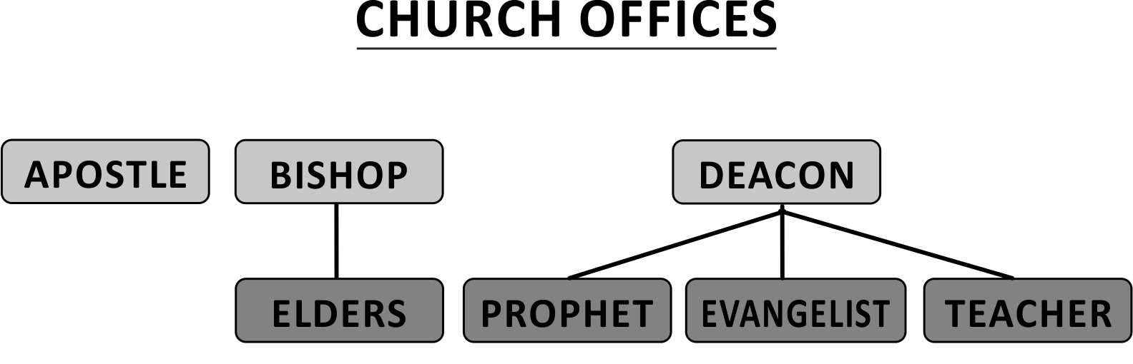

An apostle forms part of the oversight when serving together with elders in a local church.

THE APOSTOLIC TEAM

This is not a team of “Apostles” it is a team of various mature, gifted ministries united in the “Apostolic Vision” (The vision given to the apostles by Jesus).

When the Church began in Jerusalem there was clearly an apostolic team who were involved in sending various ministries into the surrounding areas. We see some of these ministries (Barnabas, Paul, Agabus, John Mark etc) referred to in Acts 11:19-30 and Acts 12:25

As the work expanded an Apostolic team developed in Antioch including men like; Barnabas, Paul, Agabus, John(Mark), Simeon, Lucius, Manaen, Judas(Barsabbas) & Silas - Acts 13-15

Paul and Barnabas then part ways, Barnabas taking John(Mark) and
Paul taking Silas and then building their respective Apostolic teams -
Acts 15:40

Paul developed an Apostolic team consisting of many men; Silas, Timothy, Aquila, Apoollos, Gaius, Aristarchus, Sopater, Secundus,
Tychicus, Trophimus, Andronicus, Junia, Urbanus, Apelles, Herodion,
Tryphena,Tryphosa, Rufus, Lucius, Jason, Sosipater, Tertius, Sosthenes, Stephanus, Fortunatus, Achaicus, Titus, Epaphras, Onesimus, Jesus(Justus), Luke, Demas, Archippus, Silvanus, Crescens, Erastus, Zena, Philemon. Onesimus and others.

This team was made up of men from various local Churches who were commended to Paul for the ministry.
Some were used regionally and others travelled all over with Paul.
This team planted, matured and expanded the work, this continued while Paul was under house arrest and after his death.

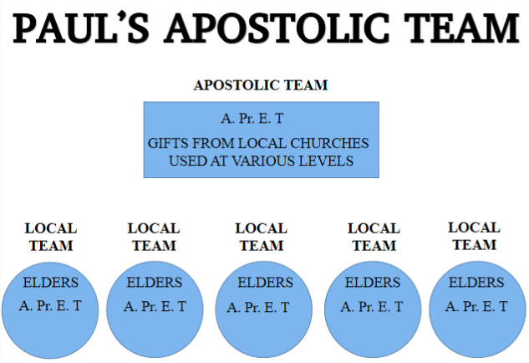

We continue to hold to this pattern today, developing Apostolic teams for the building of the Church.

LEADERSHIP:

Leadership is not about controlling, manipulating, coercing or even managing people but leading them into a common goal or vision through; teaching, inspiration and example.

We see this pattern in the early Church;
Teaching: Apostles and Teachers
Inspiration: Prophets and Evangelists
Example: Pastors

Teaching
1 Corinthians 12:8 states that God has set first in the Church Apostles, second prophets and third teachers.
This is not a hierarchy but an “order” of function.

- Apostles lay the foundation by teaching “principles”
- Prophets inspire new converts to live these “principles” ie
building on this foundation.
- Teachers will teach the doctrines ensuring the building according to
the pattern

The teaching aspect of leadership would be primarily the responsibility of Apostles and teachers.

Inspiration
We see in Ephesians 2:20 that we are built upon the foundation of Apostles and Prophets.
Clearly from above we understand the Apostles to lay the foundation hence the Prophet by description being an “Inspired preacher” would inspire the new converts to build on that foundation.

- Prophets inspire new converts to build on the foundation
- Evangelists inspire the Church to bring people onto the foundation

It would seem logical then that the leadership ministries of Prophets and Evangelists would be primarily inspirational.
Example
In 1 Peter 5:1 Peter who was an apostle makes reference to him being an elder when together in a local Church with the elders.
Now in 1 Corinthians 4:16, 11:1 and 2 Timothy 3:10-11 the Apostle Paul instructs the Church to be an imitator of himself.

The office of a “Bishop” (Elder / Pastor) has a qualification (1 Timothy 3:1-7 and Titus 1:5-9) that is primarily about example. As much as every person needs to set an example it is especially true of those in leadership and clearly from the above mentioned scriptures the Pastors are ordained once this example is clearly evidenced.

It is clear then from scripture that Pastors who are “shepherds” to the Church and are looked up to, are to be submitted to (Hebrews 13:7, 17) as they set this leadership example.
The following 5 aspects are important in leadership;
1. Character
2. Calling
3. Competence
4. Community
5. Christ

Character
The scripture is very clear concerning us being known by our fruit (Galatians 5:22-23). This is concerning character, as Gal 5:24 explains that dying to self leads to Christlike fruit. Leaders therefor need to have gone through and continue enduring the “crucifying” of the flesh to manifest the fruit of Christ. A character shaped by God is critical for Biblical leadership.

Calling
1 Corinthians 1:26, Ephesians 4:1, 2 Timothy 1:9 and Hebrews 3:1 all explain that God “calls” an individual.
Ministry is NOT a career path that we choose and then fulfil on our terms and convenience. Leadership in the Church is all based on God’s “calling” and so is according to His purpose which usually is contrary to what we want. Its doing God’s will and not ours, we do it because we love Him and we trust Him for every provision to fulfil His call.

Competence
As leaders in the Church we need to be competent in understanding scripture (2 Timothy 2:15), competent in being able to teach it and competent that we are being examples of living what we teach.

Community
Leadership is about leading people and in this application the Church, therefor leaders need to be integrally involved in the life of the Church and the lives of its members.
John 10:1-16 Jesus speaks of Himself as being the Good Shepherd who knows and lays down His life for His sheep. Biblical leaders “must know” the Church flock, it’s all about community.

Christ
Above all our leadership is “TOTALLY” centred on Christ, He alone is the focus, our vision and what we are leading people into.
This is the FIRST and SOLE purpose of the Church - bringing people into a living relationship with Jesus.

We can then conclude from the above that true leadership is taught, inspired and modeled in our character, calling and competence whereby the community of God is lead into the common vision centred on Christ

Leadership should be carried out in the following manner;
Vision
Clarity
Communication / Listening well
Decisiveness
Courage
Passion
Humility
No partiality
Taking responsibility
There are different styles of leadership;
Visionary: Mobilize people toward a vision (Apostle / Prophet)
Coaching: Develop people into the vision (Teacher / Evangelist)
Shepherding: Create unity & harmony in the vision (Pastor)

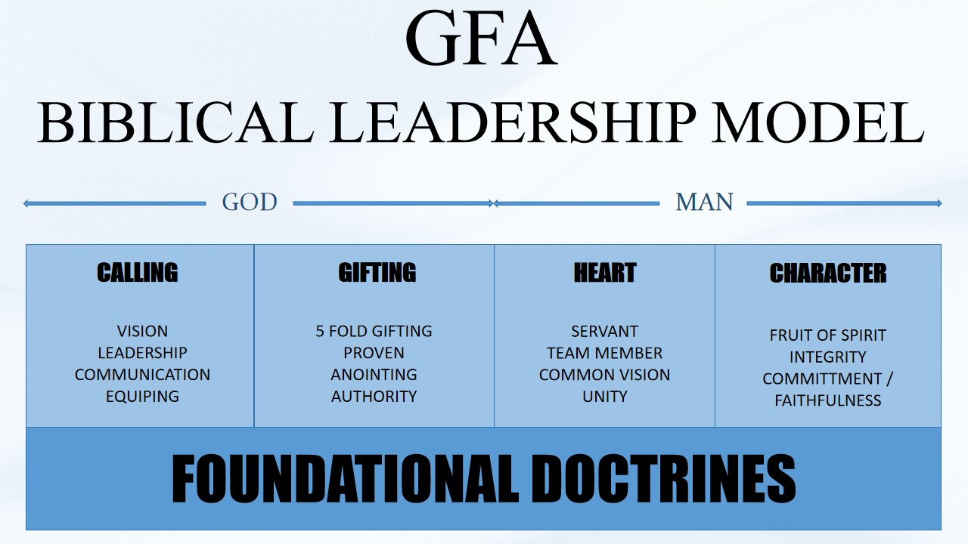

CALLING:
VISION - Proverbs 29:18, 2 Timothy 1:9, Ephesians 4:1, Romans 8:28
- Heavenly vision Jesus gave to Paul (Apostolic vision) - Acts 26:19
- Individual call to the apostolic vision (Individual gift aligned with the apostolic vision)
- Team must understand, support and promote the vision
- Different gifts will carry our different aspects of the vision
- Continually led by the Holy Spirit (Unchanging vision in a ever changing environment)
- Commitment to the practical outworking of the vision (Application is ever changing)

LEADERSHIP - Hebrews 13:7
- Servant / Sacrificial - Mat 20:20-28
- Team must be secure, courageous and confident in their identity in Christ
- Team must be impartial and not oversensitive
- Love the sheep - Know the sheep - Heart for the sheep - Feed the sheep
- Rule with humility under God given authority to maintain the vision
- Led of the Holy Spirit, given to scripture and prayer to lead the Church into the vision
- Friendship (Build genuine relationships) before function

COMMUNICATION - Hebrews 13:17
- Good communicators (Among the team and in the Church)
- Ability to clearly communicate the vision to the Church
- Ability to communicate frustration, concerns & offenses to maintain unity in the vision
- Correctly dealing with conflict in order to stay focused on the vision

EQUIPING - Ephesians 4:11-13, Acts 20:28, Colossians 1:28, 2 Timothy 3:16-17
- A heart to equip the Church in the vision
- Ability to equip the Church according to gifting
- Desiring the best in others
- Esteeming others greater than ourselves
- Developing and allowing others to move beyond where we are

GIFTING:
5 FOLD GIFTING - Ephesians 4:11-13
- A clear manifestation of Apostle, prophet, evangelist, pastor or teacher
- Confirmed by the leadership team
- Using the gift to equip the Church and not for personal gain
- Honoring and accountable to other gifts, working in unity to build the Church
Apostle: Govern
Prophet: Guide
Evangelist: Gather
Pastor: Guard
Teacher: Ground
PROVEN GIFTING - Romans 5:3-5, James 1:2-3, 1 Timothy 3:10
- Fruit confirming the gift
- Evidence of the gift in the family
- Evidence of the gift functioning in the team
- Gift being used to build the Church
- Enduring of trials, suffering and rejection

AUTHORITY - Mathew 18:18-20, 2 Corinthians 10:8
- Servant leaders who carry the authority of Christ (The gift is a measure of Christ)
- Each gift carries an authority of Christ
- Authority of each gift is different, they have different measures and spheres of influence
- Evidence of the authority of the gift
- Submission to authority of other gifting (Leadership team)

ANOINTING - Luke 4:18, 2 Corinthians 1:21-22, 1 John 2:20, 1 John 2:27
- Each gift carries the anointing of Christ (Christ means “anointed”)
- Evidence of the anointing on the gift
- Each gift carries a particular anointing according to the measure and the gift
- Acknowledging and making place for each others anointing

HEART:
SERVANT - Mathew 20:26-28, John 13:12-15, 1 Corinthians 9:19, Galatians 5:13, Philippians 2:5-7
- Servant / Sacrificial leadership
- Esteeming others greater than ourselves
- Preferring others above ourselves
- Knowing the flock
- Serving the flock
- Having no reputation
- Laying down personal agenda’s for the vision

TEAM MEMBER - 1 Corinthians 12:12-14, Romans 12:4-5, Ephesians 4:15-16
- Submission to God
- Submission to the leadership team
- Valuing the team
- Wanting the best for the team
- Committed to the team
- Accountable to the team
- Supporting the team

COMMON VISION - Philippians 2:2, Acts 4:32, 1 Corinthians 1:10, Ephesians 4:3, 1 Peter 3:8
- Buy in to THE vision (Singular apostolic vision)
- Willing to lay down my own burdens and preferences
- Actively promote the vision (As application changes according to circumstances)
- Focus on the vision in all aspects of ministry

UNITY - Acts 2:1, John 17:20-23, 1 Corinthians 1:10, Philippians 2:1-2
- Unity with Christ (His vision)
- Unity, submission, commitment and accountability to the team
- Agreement and support of the application

CHARACTER:
FRUIT - Galatians 5:22-23
- Fruit of the Repentance
- Fruit of the Spirit
- Good relationships with the team members
- Wife supporting the vision, calling and ministry
- Godly testimony at home, work and community
- Good relationships in the Church

INTEGRITY - Mathew 5:37, Luke 16:10, 1 Thessalonians 2:10, 1 Timothy 3:1-13
- Honesty
- Maintaining strong Biblical principles
- Discreet
- Undivided
- Impartial
- Transparent

COMMITTMENT / FAITHFULNESS - Mathew 25:21, 1 Corinthians 4:2
- To God
- To fulfilling the measure of Christ
- To family
- To the team
- To the Church
- To employer

Chapter 5
- SPIRITUAL GIFTS -

- Word of wisdom
- Word of knowledge
- Faith
- Gift of healing
- Working of miracles
- Prophecy
- Discerning of spirits
- Diverse kinds of tongues
- Interpretation of tongues
The above-mentioned gifts are available to every believer who is baptized into the Holy Spirit; this is a subsequent event after being baptized into Jesus (salvation).

1 Corinthians 12:7-11
Firstly, Paul states that the manifestation of the Spirit is given to EVERY MAN to PROFIT ALL.
- So, it is clear that every believer can manifest the gifts of the Spirit.
- It is also clear that the manifestation is for the profit of ALL.
Secondly, Paul states that the Spirit divides to every man severally as HE WILLS.

1 Corinthians 12:31.
Coveting the best gifts quite simply means to earnestly desire the better gifts.
It is to desire the right gift (best) for the circumstance.

For example:
- The best gifts for a marriage counseling situation would be:
Word of knowledge
Word of wisdom
Discerning of spirits

- The best gifts when praying for the sick would be:
Gift of healing
Faith
Working of miracles

- The best gifts when at a public meeting such as the breaking of bread would be:
Tongues
Interpretation of tongues
Prophecy

Every situation requires us to desire the best gifts for that moment.
Every Spirit-filled believer has the awesome privilege of desiring the best gifts to empower their ministry.
The Holy Spirit can choose to grant us the right gift for the situation, supernaturally empowering us in ministry.
This is why every believer needs to be continuously filled with the Spirit and walking in purity before the Lord that we might be a vessel fit for the Master’s use.
Without this continual empowering we will lack power in our ministries. This is why many turn to psychology and humanism to try to psychoanalyze situations, rather than earnestly desiring the gifts of the Spirit.
Let’s keep in mind that all these gifts are a supernatural IMPARTING by the Holy Spirit.
These gifts do not originate with man, and neither are they of man’s own ability.

Word of Wisdom
Strong’s Greek Lexicon: G4678
Greek: σοφία
English: sophia
Pronunciation: sof-ee'-ah
From G4680; wisdom (higher or lower, worldly or spiritual): - wisdom.

This is a supernaturally inspired word from God, to bring God’s wisdom into a situation.

Word of Knowledge
Strong’s Greek Lexicon: G1108
Greek: γνῶσις
English: gnōsis
Pronunciation: gno'-sis
From G1097; knowing (the act), that is, (by implication) knowledge: - knowledge, science.

This is a supernaturally inspired word from God, to bring God’s knowledge into a situation.

Faith
Strong’s Greek Lexicon: G4102
Greek: πίστις
English: pistis
Pronunciation: pis'-tis
From G3982; persuasion, that is, credence; moral conviction (of religious truth, or the truthfulness of God or a religious teacher), especially reliance upon Christ for salvation; abstractly constancy in such profession; by extension the system of religious (Gospel) truth itself: - assurance, belief, faith, fidelity.
This is a supernaturally imparted assurance from God, to bring faith into a situation or to a person.

Healing
Strong’s Greek Lexicon: G2386
Greek: ἴαμα
English: iama
Pronunciation: ee'-am-ah
From G2390; a cure (the effect): - healing.

This is a supernaturally imparted ability from God, to bring healing into a situation or to a person.

Working of Miracles
Strong’s Greek Lexicon: G1411
Greek: δύναμις
English: dunamis
Pronunciation: doo'-nam-is
From G1410; force (literally or figuratively); specifically miraculous power (usually by implication a miracle itself): - ability, abundance, meaning, might (-ily, -y, -y deed), (worker of) miracle (-s), power, strength, violence, mighty (wonderful) work.

This is a supernaturally imparted power from God, to bring the miraculous power of God into a situation or to a person.

Prophecy
Strong’s Greek Lexicon: G4394
Greek: προφητεία
English: prophēteia
Pronunciation: prof-ay-ti'-ah
From G4396 (prophecy); prediction (scriptural or other): - prophecy, prophesying.

This is a supernaturally imparted message from God, to bring edification, exhortation or comfort - 1 Corinthians 14:3.

Discerning of Spirits
Strong’s Greek Lexicon: G1253
Greek: διάκρισις
English: diakrisis
Pronunciation: dee-ak'-ree-sis
From G1252; judicial estimation: - discern (-ing), disputation.

Strong’s Greek Lexicon: G4151
Greek: πνεῦμα
English: pneuma
Pronunciation: pnyoo'-mah
From G4154; a current of air, that is, breath (blast) or a breeze; by analogy or figuratively a spirit, that is, (human) the rational soul, (by implication) vital principle, mental disposition, etc., or (superhuman) an angel, daemon, or (divine) God, Christ’s spirit, the Holy spirit: - ghost, life, spirit (-ual, -ually), mind.

This is a supernaturally imparted discernment from God, to expose and reveal the spirit in a situation or of men.

Diverse kinds of Tongues
Strong’s Greek Lexicon: G1085
Greek: γένος
English: genos
Pronunciation: ghen'-os
From G1096; kin (abstractly or concretely, literally or figuratively, individually or collectively): - born, country (-man), diversity, generation, kind (-red), nation, offspring, stock.

Strong’s Greek Lexicon: G1100
Greek: γλῶσσα
English: glōssa
Pronunciation: gloce'-sah
Of uncertain affinity; the tongue; by implication a language (specifically one not naturally acquired): - tongue.

This is a supernaturally imparted language from God to an individual, enabling them to pray directly from their spirit and not their brain - 1 Corinthians 14:2 and Acts 2:4-11.

Interpretation of Tongues
Strong’s Greek Lexicon: G2058
Greek: ἑρμηνεία
English: hermēneia
Pronunciation: her-may-ni'-ah

From the same as G2059; translation: - interpretation.

Strong’s Greek Lexicon: G1100
Greek: γλῶσσα
English: glōssa
Pronunciation: gloce'-sah
Of uncertain affinity; the tongue; by implication a language (specifically one not naturally acquired): - tongue.

This is a supernaturally imparted message from God, to bring edification, exhortation or comfort to men.
The gift of tongues when used in one’s private capacity is to edify the individual, but when used in the church, it needs to be accompanied by the interpretation of tongues so that the church may receive edification.

1 Corinthians 14:2-5
It is clear from the above scripture that a tongue with an interpretation would be the same as a prophecy.

Having understood the operations, administration and gifts needed for the church to function, we will now discuss God’s plan for every believer to become an active member in the church.

Chapter 6

- EVERY BELIEVER IS A PRIEST -

When we talk about the “believer priesthood” we are referring to the principle of every member of the church being actively involved in fulfilling the ministry given them by God.

Ephesians 4:1-7 and Romans 12:3
From the above scriptures we see that God gives to every believer the following:
- The MEASURE of the GIFT OF CHRIST
- The GRACE to carry the measure of the gift of Christ
- The FAITH to fulfill the measure of the gift of Christ

Romans 12:4-5 and 1 Corinthians 12:12-14
We see that the body of Christ (church) is ONE body made up of MANY members.
It is God’s purpose for every believer to function in the body of Christ according to the measure given them by God.

1 Corinthians 12:18 and Ephesians 4:11-13
It is the five gift ministries that God uses to perfect every believer, maturing them to become effective in the ministry.
Every believer, therefore, is to become involved in the ministry.
The five gift ministries have the God-given measure to equip the believers, to enable them to stir up the gift that is in them.

2 Timothy 1:6
In the light of the operations of the church as discussed in chapter 3, every believer must find their place in the body of Christ and use the measure God has given them to its fullest potential.
This will take place according to Acts 2:42: “And they continued steadfastly in the apostles’ doctrine and fellowship, and in breaking of bread, and in prayers.”

We need to see every believer develop in their measure, that the body can collectively come into the full measure of the stature of Christ - Ephesians 4:13.

This is where we enjoy God’s fullness among us as the church.
For this to happen, every believer needs to function in their measure.
This is what was enjoyed by the church in the Book of Acts and can be enjoyed by us today as it has always been God’s purpose for His church.

So, we see that:
- Every believer has a measure and therefore a part to play.
- The five gift ministries are specific measures God gives to equip the believers for ministry.

As the gift is developed it is important that the individuals character develops into conformity with Christ so as to carry the gift in a Godly way.
When the character is not right and the gift develops this leads to a disconnect where we grow in Bible knowledge and not character leading us into the common trap of hypocrisy.

Chapter 7

- WHAT ABOUT WOMEN IN LEADERSHIP? -

We need to address the topic of “Women in leadership” in the church as there is much confusion surrounding this.

Ephesians 4:7
This includes men and women, so it is clear from Scripture that every believer receives a “measure of the gift of Christ”.

1 Timothy 2:12
Here Paul makes it clear that a woman is NOT permitted to “teach or usurp” authority over a man, thereby excluding women from leadership roles over men.
If women take a leadership role in the church, they automatically have to take authority over men.
Women are clearly able to teach and lead other women and children, so there are women’s leadership roles that are under the authority of men, but never over the church.

Paul also teaches the following:
Qualifications for the office of a bishop or a deacon - 1 Timothy 3:2 and Titus 1:6-7
In Chapter 4, we discussed the five gift ministries. These are all leadership roles as they are used to administer the church. These ministries can qualify a man for the office of a bishop or a deacon.
One of the qualifications is that the man must be the husband of one wife; never are we taught that it can be a woman who is the wife of one husband.

God’s Order: God – Christ – Man – Woman
1 Corinthians 11:3, Ephesians 5:22-24 and Colossians 3:18

1 Corinthians 14:3-35 and 1 Timothy 2:11-12
This is not referring to a woman NOT speaking in the church but rather referring to her not arguing with men and thereby usurping authority over men.
We see, then, from Scripture that a woman cannot be in leadership and should not enter into discussions or arguments in the church but rather leave that to the men. However, their input in these matters needs to come through their husbands.
They should discuss the matter with their husbands at home, and the husbands can bring it to the church leadership.

Women who were helpers in the ministry
Dorcas - Acts 9:36
Lydia - Acts 16:13 and Acts 16:14-15
We see above that women are integral to ministry as helpers and are called to support the leaders.

Qualification of Widows
1 Timothy 5:9-10, Romans 16:1-15 and Philippians 4:3
Clearly, from the list of qualifications, women were of vital importance to the ministry.

Chapter 8

- TITHING & GIVING GOD’S WAY -

TITHES
Strong’s Hebrew Lexicon: H4643
Hebrew: מַעַשְׂרָה מַעֲשַׂר מַעֲשֵׂר
English: ma‛ăśêr ma‛ăśar ma‛aśrâh
Pronunciation: mah-as-ayr', mah-as-ar', mah-as-raw'
From H6240; a tenth; especially a tithe: - tenth (part), tithe (-ing).

A tithe means a “tenth”.

Tithing before the Law:
Tithing was a principle established even before the law was given to Moses - Genesis 14:18-20.

Abraham pays tithes to Melchizedek (the priest of God), who is a type of Christ - Hebrews 7:1-4.

Tithing commanded by the Law:
Three types of tithes were commanded by God:
- Tithe for the Levites (Heave Offering) - Numbers 18:21-24
- Tithe of the Feasts - Deuteronomy 14:22-27
- Tithe for the Poor - Deuteronomy 14:28-29

We see, then, that the tithes were for the following three purposes:
- Levites - To support the priesthood
- Tithers - To enjoy whatever purposes God decided
- Poor - For those who didn’t have

What did Jesus teach about tithing:
Jesus did not teach on tithing but rather on our attitude toward giving - Matthew 6:1-4, Matthew 10:8 and Acts 20:35.

Giving in the New Testament:
In the New Testament, we don’t see teaching on tithing but rather on the principle of giving.
I believe that God would not want to limit us to giving only a tenth but rather enable us to go beyond that in our giving. However, a tenth would be a good benchmark.

Christ is the fulfillment of the law, and He now indwells us by His Spirit.
As new creatures, we take on His nature – LOVE – against which there is no law.
So, if I am like Jesus and everything I do is born out of love, my giving will be in line with how He gives; generously, abundantly, sacrificially, wholeheartedly and expecting nothing in return.

So, on this basis, let’s look at Scripture regarding our giving:
1 Corinthians 16:1-2, 2 Corinthians 9:6-7 and Acts 4:32-37
We see from the above scriptures that it was a common practice in the New Testament church to give:
- As God has prospered a person
- As each person purposes in their own heart
- Not grudgingly
- Not out of necessity
- Generously
- Cheerfully
- To the Apostles

It would be correct, therefore, to encourage every believer to be Christ-like in their giving and to give as listed above.
We should give as much as we can rather than as little as possible.
We should not be limited by a tenth.
We should give as unto the Lord rather than under compulsion or to be seen by men.

What do we do with that which is given?
- We firstly support the ministry (those who are laboring).
Just as the first tithe under the law was for the Levites (priesthood), so too we first support those who are laboring in ministry.

1 Corinthians 9:7-14
Any of those with gift ministries who are laboring are eligible for support. (This is done according to needs, by agreement and funds permitting.)
Ministry is not a career, it is a “calling”, and the finances given are not a salary but rather a support.
So the amount will vary between individuals, depending on their needs.

1 Timothy 5:17-18
We see the need for supporting elders (especially those who labor in the Word and doctrine) as they will often take up a “full-time” responsibility in a church.

Some, therefore, may need full support, due to their being dedicated only to ministry and having no other form of income.
Others may only need to be subsidized to a degree as they have other forms of income.

There are other costs related to ministry, for example:
- Properties for gathering (rentals or purchases)
- Accommodation
- Transport

We have chosen the following pattern from Acts 2:44 and
Acts 4:32-35.
We endeavor to share everything we have so all the churches that are working together under our official registration in a country can benefit.
Each local church has its own bank account and will cover its own running costs.
What is left after all local expenses is then sent to a “central account”.
From the central fund we support the following:
- All full-time workers – so that there is fair support for all
- The purchase of property and other assets which are held in “trust”
- Missions
- Widows (who qualify) and orphans

This account is held in trust and administered by trustees from several of our churches.
The “trustees” are:
- Apostles – as they know the needs of the entire work
- Ordained elders and deacons – men who are recognized among us as being very astute

The apostles advise on the needs in the work, and the elders and deacons administer funds according to availability, legislative requirements and sound financial advice.

Supporting Widows
1 Timothy 5:3-16
We see from the above scripture that not every woman who has lost her husband qualifies as a “widow indeed”.
For a woman to qualify as a “widow indeed” she needs to meet the following criteria:
- Left alone - isolated
- Trusts in God
- Given to prayer
- Not given to pleasure
- Blameless
- 60 years and over
- Well reported of for good works
- Raised children
- Wife of one husband
- Hospitable
- Washed the feet of the saints
- Relieved the afflicted
- Followed every good work

It is the responsibility of family members to support widows, but if they have no family members or the family members will not take responsibility, then the church will carry the responsibility.

Supporting orphans - James 1:27
The scripture encourages us to visit orphans in their affliction.
We are not financially responsible as the church to care for orphans other than by showing compassion and mercy.
It would be doctrinally correct, then, to support orphans with “gifts and offerings” rather than tithes.

What do we do with gifts and offerings?
Matthew 10:8, Acts 2:44-46, Romans 12:13 and Philippians 2:4

According to the above-mentioned scriptures, we need to use the “gifts and offerings” for needs within the church.
These needs may vary, and each one needs to be assessed and be agreed upon by the elders.
Our first priority is to support the “local church” then the “corporate group” to which we are affiliated before we support other needs.
It would not be right to support any other ministry, venture, etc. until we have ministered to all our needs first, as people are giving for this purpose.

Chapter 9

- CHURCH DISCIPLINE -

Church discipline is almost unheard of in the modern church, due to the extent of our compromise and pursuit of political correctness.
The church has become like any other worldly club, trying desperately to attract members through its varied forms of entertainment.
This has left the so-called church in a place of great compromise as it has become impossible to bring any form of discipline into the church without offending people.

Jesus makes this profound declaration in John 18:37.
He declares that His primary purpose for coming to the earth was to bear witness to “THE TRUTH”.
So, when Jesus came, truth entered the world.
This same truth needs to continue in the world because it is only the truth that can make people free. Paul makes it clear in his writing to Timothy that the church is the “pillar and ground of truth”.

1 Timothy 3:15
It is the primary mandate of the Church of Jesus Christ to be truth in this world. The moment we lose sight of this, we are doomed.
So in order for the church to be the “pillar and ground (foundation) of truth”, we need to maintain discipline in the church.
Church discipline is not just for discipline’s sake but rather for maintaining our primary purpose in the world (truth).
If we move into error of any kind, it is essential that we be brought back to our primary purpose, and this requires discipline.

We are therefore always under various forms of discipline:
- God’s Word
- Being a member of God’s church
- Breaking bread
- Walking in the light
- Individual rebuke
- Corporate rebuke
- Public discipline

Often people confuse discipline with punishment; they are definitely not the same.
God will punish the unbeliever in in the “lake of fire” after the great white throne judgment.
God disciplines those whom He loves, with the purpose of bringing correction into our lives so that we can enjoy the fullness He has for us.

Hebrews 12:5-10 and Revelation 3:19
It is clearly evident from the above scriptures that God disciplines us because He loves us as children, and it is ultimately for our good.

General church discipline patterns:

When there is an offence or a sin by an individual in the church, we adhere to the following pattern:
Matthew 18:15-19
- Go to your brother with the purpose of “gaining” him.
- If he will not receive you, take a witness.
- If he will not receive the witness, bring it before the whole church.
- If he will not receive the church, then remove him from fellowship. This is what it means to “bind on earth”.
We agree as the church that the brother is put out of fellowship; we ask the Lord to put the man out of fellowship and to discipline him with the hope of him repenting.
This is then “bound in heaven”, so that no matter where the man goes, he is no longer in fellowship with the Lord. God will then discipline him, and if he repents, we can receive him back into fellowship.
Once we have seen the fruits of repentance, we will pray and ask the Lord to “loose” him from the discipline, and he will be restored to full fellowship.

When someone commits a sin that is serious, can bring reproach on the church and is in the public domain, we follow the following pattern:
Again, using the pattern of Matthew 18:15-19, we skip the first step as this no longer involves an individual having to gain another.
- The elders will meet with the individual who has sinned.
- The magnitude of the sin and whether it can be contained will determine the severity of the discipline.
- If the individual receives the elders, the discipline will be met out accordingly. If they do not receive the elders, then the matter is taken to the church.
- If the individual will not receive the church, then they are removed from fellowship.
- This will be applied as with point 4 in the previous pattern.

Take also into account the following scripture - 1 Timothy 5:20.
For those who receive the elders, suitable discipline according to the sin will be administered.
The following will be applied in various forms of severity and length of time:
- Restriction on socializing at meetings
- Restriction on having access to the believers
- Restriction on participation in meetings – prayer, sharing, preaching, leading, etc.

Once the fruit of repentance is evident, the discipline will slowly be lifted, removing the applied restrictions until all are removed and the individual/s are fully restored to fellowship.

When gross sexual sin is committed as was the case in 1 Corinthians 5, we follow the following pattern:
Again, using the pattern of Matthew 18:15-19, we skip the first two steps due to the severity of the sin.
We also then take into account the following scripture:
1 Corinthians 5:1-13
- The elders will meet with the individual/s to rebuke them and to put them out of the church.
- The church will then come together to “bind” on earth and, in this case, not just to ask God to remove the individual/s from fellowship but to completely remove His protection from their lives and to hand them over to Satan for the destruction of their flesh.
- If the individual/s repent, they will be brought back into the church under discipline as applied in the previously mentioned pattern.

So, we see that in all applications of discipline, the following is the purpose:
- To protect the church above the individual/s
- To bring correction to the individual/s so that they are saved.

Below are a few scriptures that deal with publicly disciplinable sins:
1 Corinthians 6:9-10, Ephesians 5:3-6 and
1 Corinthians 5:9-11

There is obviously much more one can say regarding church discipline, and it is a very sensitive topic.
This is why we need the utmost discretion and God’s leading whenever applying discipline.
The church needs to be well taught in this regard so that when discipline is applied, the church has a clear understanding and there is no division created within the church.
It is a very sensitive issue when having to discipline members of families in the church.
We need to discipline with great discretion, grace and love.
Always remember we are endeavoring to win the person back into a relationship with Christ; we never punish people.
We discipline because we love:
- First the church, which we don’t want contaminated
- Second the individuals as we care for their souls.

Chapter 10

- CHARACTER SHAPED BY GOD -

We have found it necessary to have a separate chapter on character as this is lacking in the modern Church. Men are functioning in their giftings yet their character is lacking creating much of the ungodly behavior, hypocrisy and error so commonly evidenced.

Jesus said we would be known by our fruit – Mathew 7:15-20, yet today men are primarily known by their gifts (this is satan’s strategy to get men to focus on gifting and neglect character)

Character is defined as:
- a characteristic property that defines the apparent individual nature of something.
We are therefore defined by our character.

To have “godly character” therefore implies the need for us to be defined by the character of God.
We need to model the character of Jesus.

2 Peter 1:2-4
Peter makes it abundantly clear here that we have been given all we need to become partakers of the divine nature of God.

Character is a spiritual fruit that is built from our real, godly relationship with and commitment to Christ as LORD. It is the fiber of our moral center that stretches throughout our being, embracing and holding together our relationships when it is sealed as a choice and commitment, and not just a feeling or a personality. Character combines with the fruit of the Spirit and the many other characteristics of our Lord to promote our ability to relate and grow in our relationships, to better others as well as ourselves.

John 3:30 teaches that we must decrease and He (Jesus) must increase.
Below is a list of godly qualities that He calls us to emulate and put into our relationships. These are essential to growing a healthy and lasting relationship. You can examine the descriptions, look up the scriptures, and then ask yourself these six questions:
- Is this quality working in me?
- How do I now exhibit this quality in my daily life?
- How can I use this quality to develop a greater willingness to respond to others – especially the ones I love – with a sense of awe, and fear of God, and respect for people?
- What blocks this quality from working and being exhibited in me?
- How can I make this quality function better, faster, and more strongly, even in times of uncertainty and stress?
- What steps would I need to take to put this quality into action in a specific instance, or to improve it?

Consider the examples from the passages in God's Word:

Galatians 5:22-23 - The Fruits of the Spirit
Love will enable us to appreciate our brothers and sisters in the Lord, including our family, and others around us. Love is taking the initiative to build up and meet the needs of others without expecting anything in return (John 13:1, 15:13 and 1 Corinthians 13:3).
Joy will allow us to enjoy His creation, others, and our circumstances with an expression of delight and real, authentic happiness from and in harmony with God and others (Proverbs 15:13 and John 15:11, 17:13).
Peace is surrendering and yielding to the Lord's control, for He is our ultimate peace! It is allowing tranquility to be our tone and to control our equanimity. This will be fueled by our harmonious relationship with God so we can hand over control of our heart, will and mind to Him. Once we make real peace with God, we will be able to make and maintain peace with others (Matthew 5:9, Colossians 3:15 and Philippians 4:7).
Patience is showing tolerance and fortitude to others, and even accepting difficult situations from them and God without making demands and conditions (Matthew 27:14, Romans 12:12 and James 1:3, 12).
Kindness is practicing benevolence and a loving attitude towards others (Ephesians 4:32).
Goodness displays integrity, honesty and compassion to others, and allows us to do the right thing (Matthew 19:16).
Faithfulness is the "gluing" fruit that will preserve our faith and the other characteristics of the Spirit, as well as identify God's will so we can be dependable and trustworthy to God and others (Matthew 17:19, 25:21, 1 Corinthians 12:9, Hebrews 11:1 and 1 Thessalonians 5:24).
Gentleness has the characteristics of calmness, personal care, and tenderness in meeting the needs of others (Isaiah 40:11, Philippians. 4: 5, 2 Timothy 2:24 and 1 Thessalonians. 2:7).
Self-Control will allow us to have discipline and restraint, with obedience to God and others (1 Thessalonians 5: 22).
Additional Biblical Fruits (I have added this list because Godly character is essential to leadership.)
Forgiving is the realization of how much we have been forgiven by Christ. This enables us to forgive the insignificant things that are done to us. It involves not being resentful towards others and ignoring the wrongs that we have received so we can heal relationships by expressing Christ's love (Luke 23:34, Ephesians 4:32 and Colossians 3:13).
Humility minimizes arrogance and removes pride. It is understanding our fallen nature, our tendency to think we are better than we are, and our striving to lift ourselves above others and God. It is admitting that others, and more importantly God, are responsible for our achievements. Humbleness will enable us to be a teachable person with an attitude of submission and servanthood, one who confesses sin and remembers how Christ served us (Luke 22:27, Philippians 2:8 and 1 Peter 5:3-5).
Fairness sees a situation from the viewpoint of each person involved and not just ours. It seeks the most just and equitable solution, even if it hurts us (Matthew 7:12).
Courage realizes that God has given us the strength to face any situation, trial or peril. It is the ability to react knowing that God is in control, that He who is in me is greater than he who is against me (Deuteronomy 31:6 and 1 John 4:4).
Friendship is the companionship and closeness we are to have with one another. It is the commitment to help form a godly character in others. This is not to be feared but embraced, even when it hurts (Proverbs 27:17).
Honesty & Truthfulness mean being straight and honest with others and doing what is right. This trait allows us to earn trust by being accurate with facts and situations (2 Corinthians 8:21 and
Ephesians 4:25).
Dependability is being constantly reliable and trustworthy. It allows us to continue in our commitments, even if it means personal sacrifice (1 Corinthians 4:2 and Colossians 1:10).
Gratitude is an attitude of being thankful, even when we do not see what we have. This is an aspect of worship, expressing to God and others how they have benefited our lives by showing their support and benevolence (1 Corinthians 4:7 and 1 Thessalonians 5: 18).
Responsibility is knowing and doing what God and others expect (Romans 14:12).
Contentment is the attitude of accepting whatever God provides for us and being happy with it. It does not seek what we do not need for gratification and does not find happiness in the shallow things of life (Romans 9:19-21, Philippians 4: 10-13 and 1 Timothy 6:6-9).
Generosity allows us to give to others because God has given abundantly to us. It is the attitude that all I have belongs to God and knowing we are the caretakers for His purpose (Deuteronomy 16:17 and Matthew 10:8).
Purity & Holiness mean being set apart for God's use, which is holiness in action. It does not allow us to be contaminated or interfere with others in our growth and relationships in Christ (Matthew 5:8, Philippians 4:8, 1 Timothy 1:5, 5:22 and James 4:8).
Confidence helps us rely on the Lord for all things in our life. It enables us to push forward in the direction that we are called because He is governing. It makes us realize we are not responsible for the results -- only the obedience (Philippians 4:13).
Encouragement will lift, support and help others up through difficult circumstances, all from God's perspective (Psalm 119:28, 143:3, Matthew 3:17, John 14:1 and 1 Thessalonians 5:11-14).
Availability is being willing to adjust our own schedule, agenda and plans to fit the right desires of God and others. It makes personal priorities secondary to the needs of God and others. It is to reflect God's priorities so we are always available to Him and others when we are serving (Mark 1:17-18 and Acts 16:10).
Attentiveness recognizes the value of other people by giving them listening ears, respect, courtesy and total concentration. This means paying attention to others, not just listening to our own needs and desires, but also giving genuine contemplation to God's Word (Hebrews 2:1).
Wisdom truly desires the knowledge of God's Word and the proper application to our life. This enables us to make good judgments and decisions (1 Kings 3:9 and Psalm 119:97-98).
Compassion feels the pain and plight of others. It enables us to convey a deep feeling of love and concern that moves us to alleviate their distresses and struggles and meet their needs (Job 29:13, Isaiah 40:11, Mark 1:41 and 1 Peter 3:8).
Enthusiasm enables us to overcome disappointments and setbacks so we can be positive and optimistic and keep up our interest, attitude and zeal, even when things are harsh (Matthew 5:16,
Romans 12:11, Galatians 6:9 and Colossians 3:23).
Initiative takes the front position to recognize and do what needs to be done before being asked to do it (Proverbs 22:29 and Philippians 3:14, 4:13-15).
Diligence allows us to operate with our best for His highest, with excitement and passion, in order to complete our work and call from the Lord (Proverbs 10:4, Romans 12:11 and Colossians 3:23).
Thoughtfulness considers and gives attention and care to others and their feelings first (Philippians 2:4).
Efficiency is being well organized, competent and resourceful so we can make the most of every situation, doing our best and seeking better ways (Psalm 90:12, Ephesians 4:23, 5:15- 16 and
1 Peter 4:10).
Discretion keeps our minds and focus on sound judgment, giving serious attention and thought to what is going on. It ensures our words, attitudes and actions are right for any given situation, thus avoiding words and actions that could have adverse consequences (Psalm 112:5, Proverbs 22:3 and
Romans 12:2, 9, 14:19, 22).
Optimism thinks the best of people and situations, even if later proven wrong (Luke 21:18, John 16:33 and Romans 8:25, 28).
Obedience is submitting to doing what God requires of us. It is also recognizing the authority of and direction from others, such as the pastors and church, so we can create oportunistic situations (Deuteronomy 13:4, Proverbs 19:16, John 14:15, 15:14
and 2 Corinthians 10:5).
Reverence is recognizing and respecting people, not just because of their position and authority but as brothers and sisters in the Lord, regardless of their personality, knowing He loves them too.
(1 Peter 2:13-14).
Appreciation gives God our heartfelt thanks as a lifestyle of worship and adoration. This allows us to give to, and value, others with respect (Romans 12:10).
Commitment is being dedicated and pushing ahead, as well as being satisfied with what you have. It is vowing to honor and be the best with what God has given of spiritual and material things.
(1 Timothy 6:20).
Communication is being willing to convey thoughts, attitudes, feelings and actions to others in a kind and listening manner that reflects Christ (1 Timothy 4:12).
Conviction is devotion to and following the precepts of Scripture with zeal, whatever the cost (Daniel 1:8).
Cooperation is support and the willingness to work together in peace, unity and harmony (Ephesians 4:3).
Determination is the ability to make difficult decisions and accomplish God's goals based on the truths of God's Word, regardless of the opposition (Psalms 119:30 and 2 Timothy 4:7, 8).
Diligence means loving our call and pursuing our work, doing our best for His glory (Colossians 3:23).
Discernment is the ability to see people and situations the way they really are, with neutrality and justice, while also being cautious about right timing and actions (1 Samuel 16:7 and Proverbs 19:2).
Discipline is upholding and continuing a consistent and well-ordered life through godly obedience, regardless of how we feel.
(1 Timothy 4:7).
Endurance is the inner strength to remain in Him in order to accomplish God's will (Galatians 6:9).
Fearlessness is facing down peril without being stupid. Having a sound mind enables us to be bold since God gives us strength (2 Timothy 1:7).
Flexibility is being open to others’ plans and ideas and willing to be instructed and challenged to change for the better (Colossians 3:2).
Hospitality is a willingness to share, with discernment, what God has given us, including our family, home, finances, and food
(Romans 12:13).
Integrity is obedience to a moral code of values based on honor, truth and reliability. It allows one to keep one’s word and do one’s best, even when no one else is looking (Psalm 78:72).
Justice entails doing what is fair, moral, impartial and right, according to God's will (Genesis 6:9).
Loyalty is remaining committed to those whom God has brought into our lives and has called us to serve, even in times of difficulty (Proverbs 17:17).
Meekness is not about being weak! It is strength under control, which yields personal rights and expectations to God (Psalms 62:5).
Mercifulness is demonstrating more forgiveness and gracious kindness than the world requires (Luke 6:36).
Patience is the fortitude to accept from others difficult situations that we do not like. With God, it is trust in His timing and not giving Him a deadline (Romans 12:12).
Perseverance is not being faint with our call but persisting and dealing with stress so that we can accomplish what God calls us to (Galatians 6:9).
Persuasiveness advocates God's Word to others so they can be changed in their thinking and can conform to His will
(2 Timothy 2:25).
Promptness results in not holding others back with our inadequacies; it is respecting the time of others and being able to act quickly when God and others call on us (Ecclesiastes 3:1).
Prudence is not being a prude but applying good, logical and just judgment to situations that will help in avoiding error and problems (Proverbs 13:6, 22:3).
Purpose is in knowing who we are in Christ and acting out our call, that is, devoting our life, spiritual gifts and abilities to bring out the best in people and situations. Our lives will have eternal meaning and results (John 15).
Respect means being polite and courteous to the people and civil authorities God has placed in our life (1 Thessalonians 5:13-13).
Selflessness is the sacrificial giving of ourselves to others, as Christ gave Himself to us (Titus 2:14).
Sensitivity is exercising kindness and compassion so we can go beyond just reason and logic to perceive and respond to others (Romans 12:15).
Servant leadership is exercising real godly leadership as Christ did through example, influencing, equipping and empowering people to accomplish God's purpose and plan (Luke 22:26).
Sincerity is earnest honesty that readily does what is right, with pure and loving intention (Joshua 24:14 and 1 Peter 1:22).
Submission is surrendering, with awe and reverence, and yielding our will and plans to God's guidance (Ephesians 5:21).
Suffering is not sought, but when it happens, it can shape us for the better, as "Christ hath suffered". It is not a personal attack; rather it is a means to get our attention to make us better, stronger, more useful, and to understand what takes place in others (1 Peter 4:1-19).
Tact is being considerate, delicate and diplomatic with another’s feelings and ideas; doing, and saying the right thing (Colossians 4:6).
Tolerance is being forbearing and patient with others, even when they are different or weaker (1 Thessalonians 5:14).
Virtue is holding onto the principles of moral excellence that call us to a higher level where few people desire to go but, as Christians, we must go (Colossians 3:12-17).
Zeal is maintaining our enthusiasm for our faith and call, not allowing our church or ourselves to fall into a rut of meaningless rhetoric (Luke 2:49 and John 2:17, 8:29).

There are dozens more godly characteristics illustrated in the Bible, which God calls us to embrace and apply in our lives. Remember, these all combine to help create the mature, Christ-like Christian. What Christ gives to us in grace, and how we respond towards others around us, are essential in all of our relationships.
When the other ingredients of a good relationship are right, then the love will come. Love does not stand alone; it needs to be in synergy with good character, a good attitude, and reverence so that we can stroll through the maze of relationships with confidence and the assurance that Christ is lighting our path.
STEWARDSHIP

1 Corinthians 4:1-2
All of life is a stewardship, from learning to look after possessions (no matter the value) when a child, caring for siblings and taking care of your first vehicle and home to laying your life down for your spouse and raising Godly children.
We need to learn to be stewards from our youth, seeing as everything we have, we have received as a gift from God (it all belongs to Him).
He has entrusted much into our care; we need to be “good stewards” who will give an account to Him one day.
Consider this parable spoken by Jesus regarding stewardship - Matthew 25:14-30.

The foundational principle in exercising Godly character is stewardship, where my whole life is lived for the “glory of God” - John 15:8.

Chapter 11

- STRONG FAMILY UNITS -

This chapter has been added for the express reason that if a man called by God is actively involved in ministry and is married, he needs to have his marriage in order.
If a man’s marriage fails, he is automatically disqualified from the church offices of bishop and deacon and his testimony is adversely affected. He can be restored, but this will take time, and there will unfortunately always be a reproach on his ministry. If you are married or need to marry, this is your FIRST and GREATEST responsibility in ministry before you preach to anyone else.

Marriage is an institution designed by God with the purpose of man’s having a helper - Genesis 2:20-24.
It is not good for man to be alone because, for the most part, man needs a helper - 1 Corinthians 11:8-9.

However, Paul also suggests a man who is able to exercise self-control (1 Corinthians 7:7-9) should remain single as he can then give himself totally to the Lord - 1 Corinthians 7:28, 32-38.

It is therefore clear from Scripture that the primary purpose for marriage is to avoid sexual immorality - 1 Corinthians 7:1-6.

Secondary to this is to then enjoy God’s full purpose and benefit of a marriage - Ephesians 5:22-33.
Marriage in Christ is the most fulfilling experience a human can enjoy as each gives themself to the other, ministering to and meeting each other’s needs, physically, emotionally and spiritually.
This is a powerful expression to humanity of Jesus and His Church. (Our marriages need to be exemplified in this picture.)

GOD HATES DIVORCE!!!

If a marriage portrays Jesus and His Church, divorce would be symbolic of a separation of Jesus from His Church. God has promised to never “leave or forsake” us - Hebrews 13:5.
Men should love their wives as Jesus loves His church.
God therefore cannot ever be pleased with divorce, but knowing the hardness of men’s hearts, He allowed for this in the Old Covenant but makes it clear that if a person remarries, they commit adultery. If a person cannot remain single, they would then have to face the reality of not giving up on their marriage and find God’s grace to make it work.
We appreciate that various situations can be very complicated, and as church leaders we would need to address these on their merits as we find God’s wisdom in the individual situations - Mark 10:2-12.
Scripture only makes place for divorce if a spouse commits adultery - Matthew 5:32, 19:9.
Yet our counsel is always to reconcile if at all possible.

THE FAMILY UNIT

A good Christian family is one that lines up with biblical principles and one in which each member understands and fulfills his or her God-given role. The family is not an institution designed by man. It was created by God for the benefit of man, and man has been given stewardship over it. The basic biblical family unit is comprised of one man, one woman (his spouse) and their offspring or adopted children. The extended family can include relatives by blood or marriage such as grandparents, nieces, nephews, cousins, aunts, and uncles. One of the primary principles of the family unit is that it involves a commitment ordained by God for the lifetime of the members. The husband and wife are responsible for holding it together, the current attitude of our culture notwithstanding. Although divorce is sought and granted much too easily in our society, the Bible tells us that God hates divorce - Malachi 2:16.
The objective is for all family members to be Christians, having a true relationship with Jesus Christ as their Lord and Savior.
Ephesians 5:22–26 provides the guidelines for husbands and wives in a Christian family. The husband is required to love his wife as Christ loved the church, and a wife should respect her husband and willingly submit to his leadership in the family. The husband’s leadership role should start with his own spiritual relationship with God and then flow to instructing his wife and children in scriptural values, leading the family into biblical truth. Fathers are instructed to bring up their children in “the training and instruction of the Lord” - Ephesians 6:4.
A father is also to provide for his family. If he does not, he “denies the faith and is worse than an unbeliever” - 1 Timothy 5:8.
So, a man who makes no effort to provide for his family cannot rightly call himself a Christian. This does not mean that the wife cannot assist in supporting the family – Proverbs 31 demonstrates that a godly wife may surely do so – but providing for the family is not primarily her responsibility; it is her husband’s.
Woman was given to man for the purpose of being her husband’s helper (Genesis 2:18–20) and to bear children. The husband and wife in a Christian marriage are to remain faithful to one another for a lifetime. God declares equality of worth in that men and women are created in God’s image and are therefore equally valuable in His eyes. This does not mean, however, that men and women have identical roles in life. Women are more adept at nurturing and caring for the children, while men are better equipped to provide for and protect the family. Thus, they are equal in status, but each has a different role to play in a Christian marriage.
A Christian marriage, foundational to a Christian family, follows the biblical instructions concerning sex. The Bible counters the cultural view that divorce, living together without being married, and same-sex marriage are acceptable in God’s eyes. Sexuality expressed according to biblical standards is a beautiful expression of love and commitment. Outside of marriage, it is sin.
Children are given two primary responsibilities in the Christian family: to obey their parents and to honor them - Ephesians 6:1–3.
Obeying parents is the duty of children until they reach adulthood, but honoring parents is their responsibility for a lifetime. God promises His blessings on those who honor their parents.
Ideally, a Christian family will have all members committed to Christ and His service. When a husband, his wife, and their children all fulfill their God-appointed roles, then peace and harmony reign in the home. If we try to have a Christian family without Christ as Head or without adhering to the biblical principles the Lord has lovingly provided for us, the home will suffer.

Dedication of children

Child dedication is a symbolic ceremony undertaken by Christian parents soon after the birth of a child.
For water baptism, a person needs to “believe” on Jesus before being baptized by full immersion. A young child, especially a baby, would not have developed the capacity to believe, and on this basis, we do not believe in “infant baptism”.
Dedication rather is intended to be a public statement by the parents that they will train their children in the Christian faith and seek to instill that faith in them.
The congregation often responds through responsive reading or some other method to affirm that they, as a church family, will also seek to encourage the parents to bring up the child in the faith. There is no implied salvation in the ceremony, and it varies from church to church.
The idea of dedicating a child to the Lord can certainly be found in the Bible. Hannah was a barren wife who promised to dedicate her child to God if He would give her a son - 1 Samuel 1:11.
Luke 2:22 begins the account of Mary and Joseph taking Jesus to the temple after forty days in order to dedicate Him to the Lord. This was slightly more involved since it involved a sacrifice, but once again this ceremony did not indicate any level of salvation.
Child (baby) dedication is not one of the two ordinances (baptism and the Lord’s Supper) required of Christians in the New Covenant. As Christians, we are baptized and participate in the Lord’s Supper as outward and public signs of what Christ has done within us. While baby dedication is not an officially instituted ordinance of the church, there does not seem to be any conflict with Scripture as long as parents do not view it as assuring the salvation of the child.

Chapter 12

- WHAT HAPPENS AT THE END? -

The study of the “End Times” (eschatology) is enormous, complex, and requires much elaboration, so for our purposes we will give only a brief outline by providing a skeleton on which you can build.

Our understanding of end time events is determined by our positioning of the “millennium” (1000-year reign of Christ). All Scripture pertaining to the last days is interpreted from this viewpoint.

There are three primary millennial positions:

- Premillennialism: The millennium will start at the second coming of Christ; this is future.
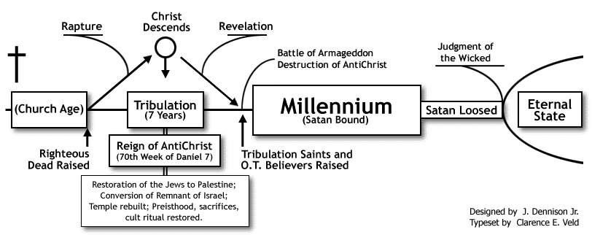

Premillennialism advocates the following:
- The millennial reign begins at the second coming of Christ.
- Satan is the god of this world until Christ’s return. ONLY then is he bound.
- Christ physically returns to Jerusalem, from where He reigns.
- Christ brings an end to all human rule and sets up His eternal kingdom, physically on earth.
- The resurrected saints return with Christ physically to reign with Him.
- Satan is physically bound and has no influence on the earth until the end of the millennium.
- Satan will be loosed at the end of the millennium; he will deceive the nations into a war against Christ called the battle of Gog and Magog where they will be destroyed.
- Satan will be cast into the lake of fire.
- All the unrighteous will face the final judgment (great white throne) and be cast into the lake of fire.
- This earth as we know it is destroyed and Christ creates a new heaven and earth in which ONLY the righteous dwell.

- Amillennialism: There is no millennium, it is only symbolic.
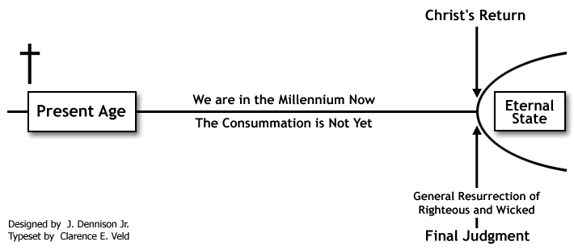

Amillennialism advocates the following:
- The millennium is only symbolic.
- The church has replaced Israel (no 70th week of Daniel nor any prophetic purposes remain).
- There is no tribulation period (this was all fulfilled in 70AD with the destruction of the temple).
- There is no rule of the antichrist (Nero was the antichrist during the above-mentioned period).
- There is no future battle of Armageddon.
- There is no rapture of the church, only a general resurrection at the return of Christ.
- Satan is not physically bound during the millennium.
- The church is currently ruling with Christ.

- Postmillennialism: The millennium is a “golden age” of Christian ethics that concludes with the second coming of Christ. We are currently in the millennium.
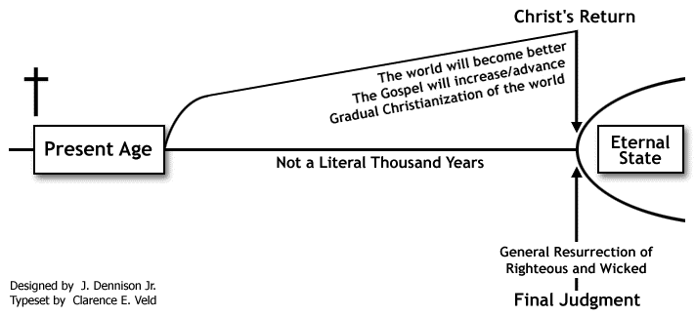

Postmillennialism advocates the following:
- The church will have growing rule over time, culminating with the second coming of Christ.
- The church has replaced Israel (no 70th week of Daniel nor any prophetic purposes remain).
- There is no tribulation period (this was all fulfilled in 70 AD with the destruction of the temple).
- There is no rule of the antichrist (Nero was the antichrist during the above-mentioned period).
- There is no future battle of Armageddon.
- There is no rapture of the Church, only a general resurrection at the return of Christ.
- Satan is not physically bound during the millennium.
- The church is currently ruling with Christ.
- The world gets better, not worse (less Christian persecution).
- The church will Christianize the world, resulting in a moral increase until Christ returns.

We believe the premillennial view to be biblical.

Based on the premillennial view, the following events still need to happen:
- Rise of the 10 kings - Revelation 13:1-10, 17:12-18 (globalists who take control of the earth)
- Great apostasy and Christian persecution -
2 Thessalonians 2:1-12 (as a result of globalist control)
- Rapture of the Church - 1 Thessalonians 4:13-18
- Ezekiel 38-39 war (Israel invaded by Russia, Iran, Turkey, Ethiopia and Libya)
- Abomination of desolation - Daniel 12:11 and Matthew 24:15 (Satan enters the temple and declares himself to be god.)
- Reign of the antichrist for 3½ years - Daniel 12:11
- Persecution of Israel - Matthew 24:15-22
- Battle of Armageddon - Revelation 16:13-16
- Second coming of Christ - 1 Corinthians 15:23-26

NOTE: It is critically important to always remember the following in light of “End Times” teaching:
- Jesus ONLY sets up His kingdom at His second coming. (It is not set up by men.)
- Satan, therefore, is the god of this world until Christ’s second coming.

Errors that originate from Amillennial and Post-Millennial views:

Dominion Theology
Dominion Theology is a grouping of theological systems with the common belief that society should be governed exclusively by the law of God as codified in the Bible, to the exclusion of secular law. The two main streams of Dominion Theology are “Christian Reconstructionism” and “Kingdom Now Theology”. Though these two differ greatly in their general theological orientation (the first is strongly Reformed and Neo-Calvinistic, the second is charismatic), they share a postmillennial vision in which the Kingdom of God will be established on Earth through political and (in some cases) even military means.

The name "Dominion Theology" is derived from Genesis 1:28, where God grants humanity "dominion" over the Earth.

REMEMBER: WHEN ADAM FELL, HE LOST HIS DOMINION TO SATAN - Ephesians 2:1-2 and 2 Corinthians 4:4. Satan is the god of this world and will be until the second coming of Christ. Only at this point will Christ take dominion and set up His kingdom -
1 Corinthians 15:23-26.

Christian Reconstructionism
An example of Dominionism in reformed theology is Christian Reconstructionism, which originated with the teachings of R.J. Rushdoony in the 1960s and 1970s. Rushdoony's theology focuses on theonomy (the rule of the Law of God), a belief that all of society should be ordered according to the laws that governed the Israelites in the Old Covenant.
Christian Reconstructionism is reformed theology that strongly emphasizes the sovereignty of God over human freedom and action, and denies the operation of charismatic gifts in the present day (cessationism); both of these aspects are in direct opposition to Kingdom Now Theology.

Kingdom Now Theology:
Kingdom Now Theology is a branch of Dominion Theology which has a following within Pentecostal and charismatic circles and was popularized in the late 1980s.
Kingdom Now Theology states that although Satan has been in control of the world since the Fall, God is looking for people who will help him take back dominion. Those who yield themselves to the authority of God's apostles and prophets will take control of the kingdoms of this world (7 Mountains).
The main promoters of this movement are the “Latter Rain” and “New Apostolic Reformation” proponents.

So when will the church be raptured?
Most of the Old Testament prophets, as well as Paul, Peter and John, spoke of the “Day of the Lord” as a day of darkness, vengeance, sorrow and wrath. This is not a specific day but rather a period of time beginning after the opening of the sixth seal (Revelations 6:12-17) and concluding at the “great white throne judgment”. The “Day of the Lord” is the period when Jesus begins to pour out His wrath
(Revelation 6:16-17) upon the world, returns to destroy His enemies at Armageddon, puts an end to the rule of man and sets up His everlasting kingdom. The kingdom is initially established on the earth where the world is ruled by Jesus with a rod of iron and concludes with the “great white throne judgment”. The day of the Lord then comes to an end, and Jesus creates a new heaven and earth.
We believe the church will escape the “Day of the Lord” as Paul teaches that we escape the “wrath that is to come” -
1 Thessalonians 5:1-11.
We see in Bible typology that God always has a rescue mission before His wrath is poured out ie: Noah and Lot. So what is clear from Scripture is that the church will be raptured before the “Day of the Lord”.

This day is fast approaching; we, the church, need to return to the teachings of the Apostles in earnest contention for the faith that was once and for all delivered to the saints, as instructed by Jude (Jude 1:3). It’s time to be discerning and watchful. To walk in total surrender and obedience to Christ as we prayerfully await that great and dreadful “Day of the Lord” which will come upon the whole world. And to this end, Paul reminds the church that we are children of “the day” and that we will escape the “wrath” that is to come -
1 Thessalonians 5:1-11.

Our prayer is that the Holy Spirit will give you revelation and understanding of the Scriptures and that you will experience God’s unfailing grace as you walk in the light of the teachings of the Apostles.
To church leaders, may God grant you great wisdom in building the church upon this foundation.

Watch! Stand fast in the faith!
Be men! Be strong!

1 Corinthians 16:13

